**PySpark withColumn() Usage with Examples**

PySpark withColumn() is a transformation function of DataFrame which is used to change the value, convert the datatype of an existing column, create a new column, and many more. In this post, I will walk you through commonly used PySpark DataFrame column operations using withColumn() examples.

* [PySpark withColumn – To change column DataType](https://sparkbyexamples.com/pyspark/pyspark-withcolumn/#change-datatype)
* [Transform/change value of an existing column](https://sparkbyexamples.com/pyspark/pyspark-withcolumn/#transform-column)
* [Derive new column from an existing column](https://sparkbyexamples.com/pyspark/pyspark-withcolumn/#derive-new-column)
* [Add a column with the literal value](https://sparkbyexamples.com/pyspark/pyspark-withcolumn/#add-new-column)
* [Rename column name](https://sparkbyexamples.com/pyspark/pyspark-withcolumn/#rename-column)
* [Drop DataFrame column](https://sparkbyexamples.com/pyspark/pyspark-withcolumn/#drop-column)

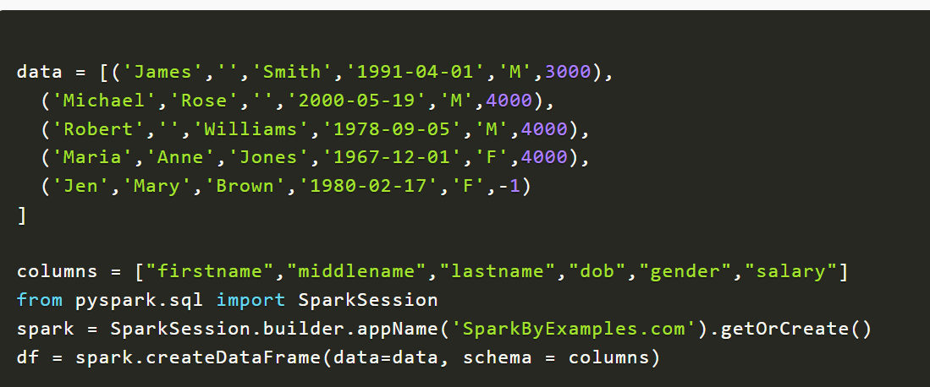

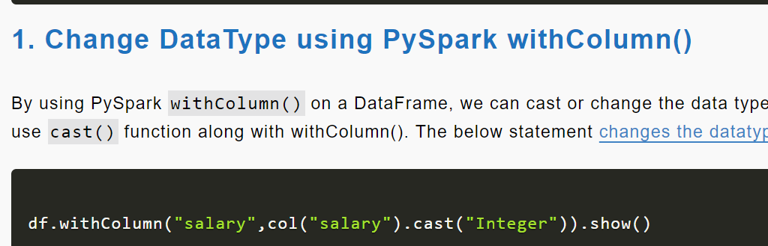



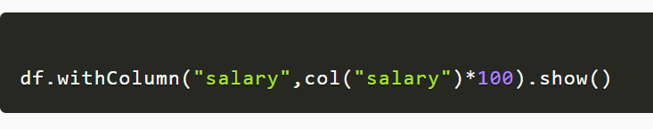

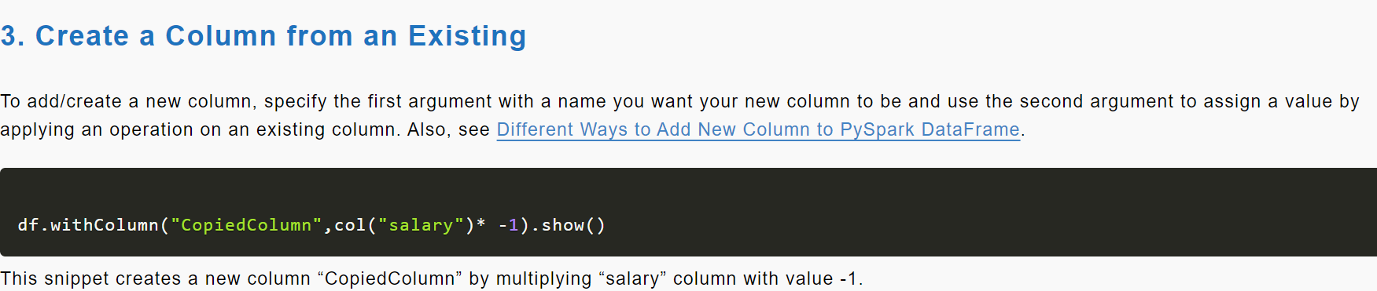

Name of new colum

New column values generated from old

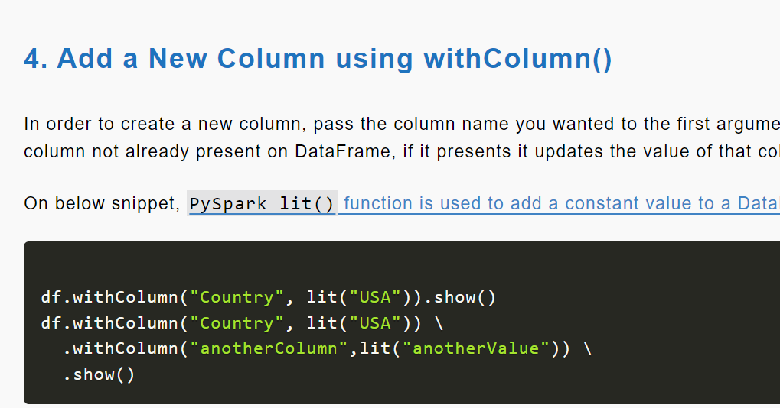



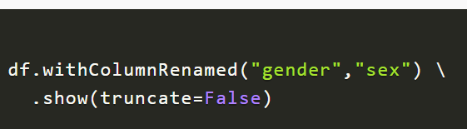

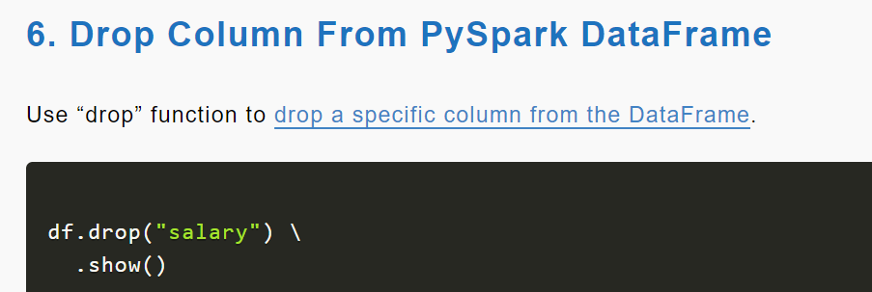

**PySpark Where Filter Function | Multiple Conditions**

Filter()

Where()

Isin()

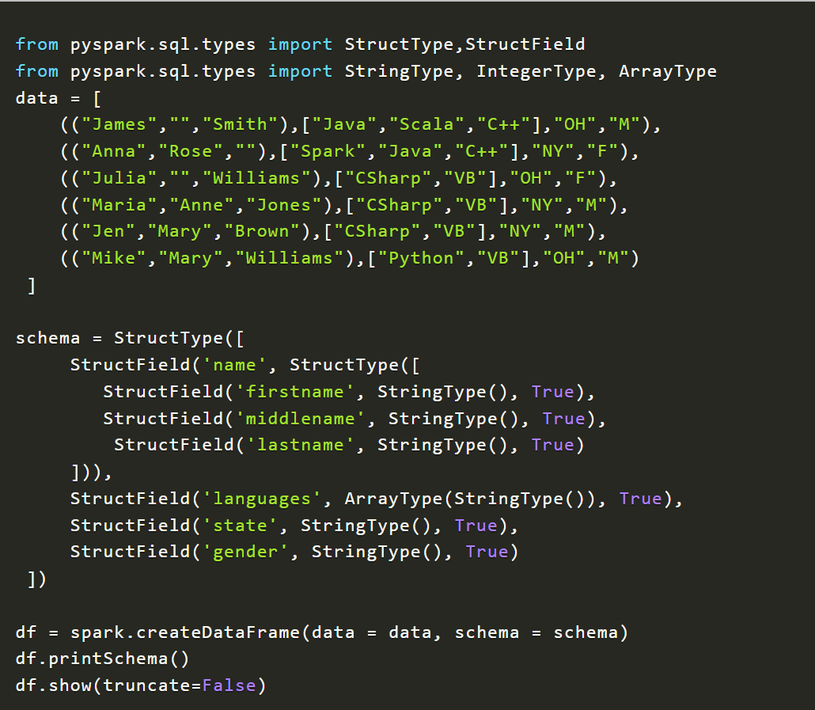

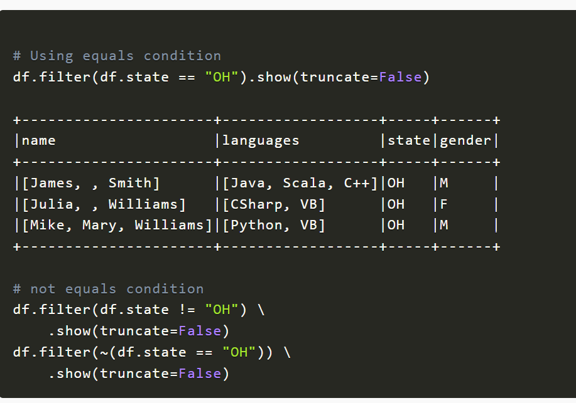

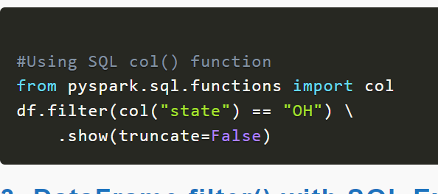



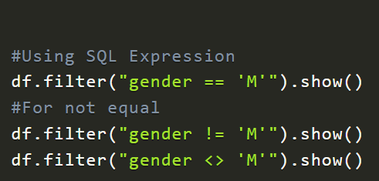

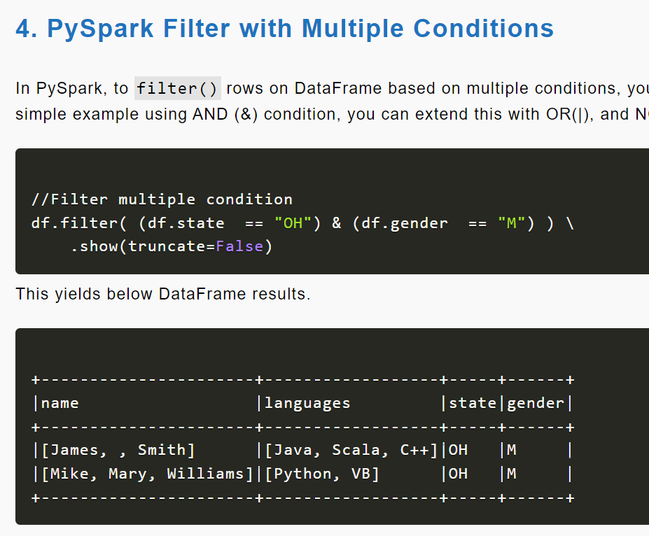

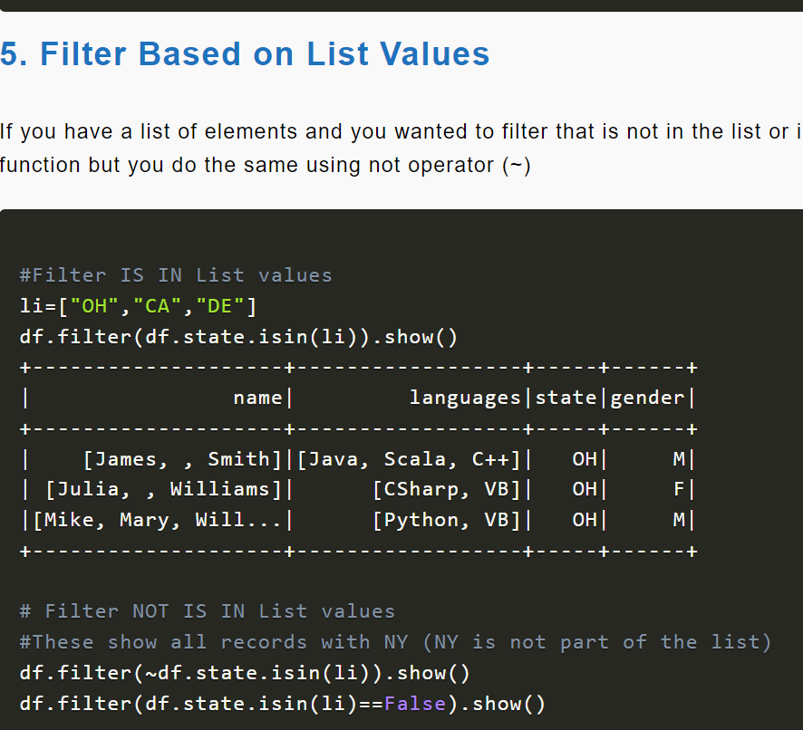

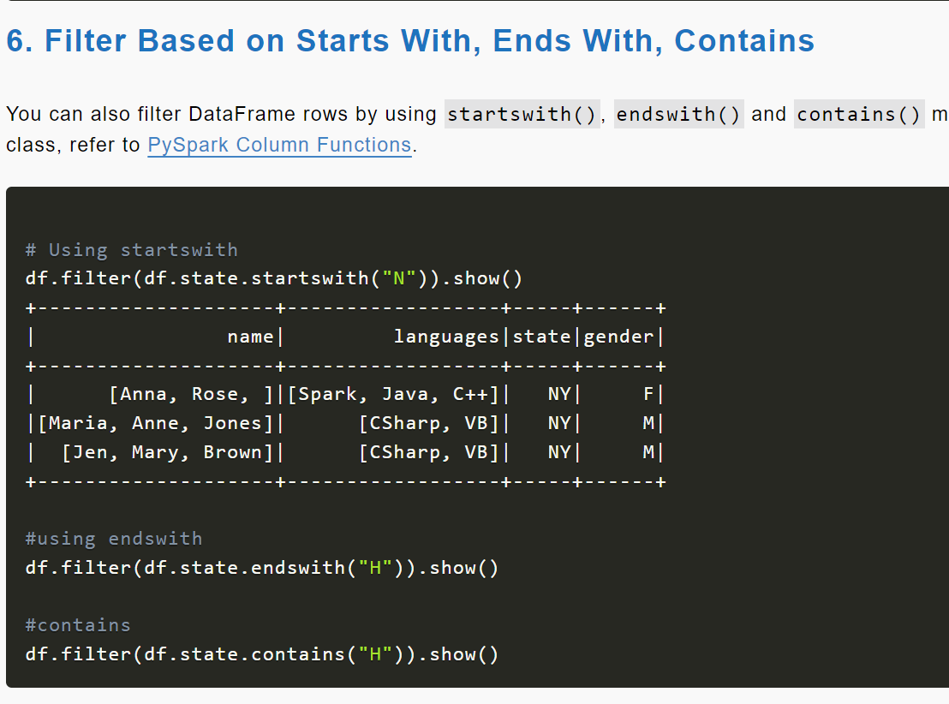

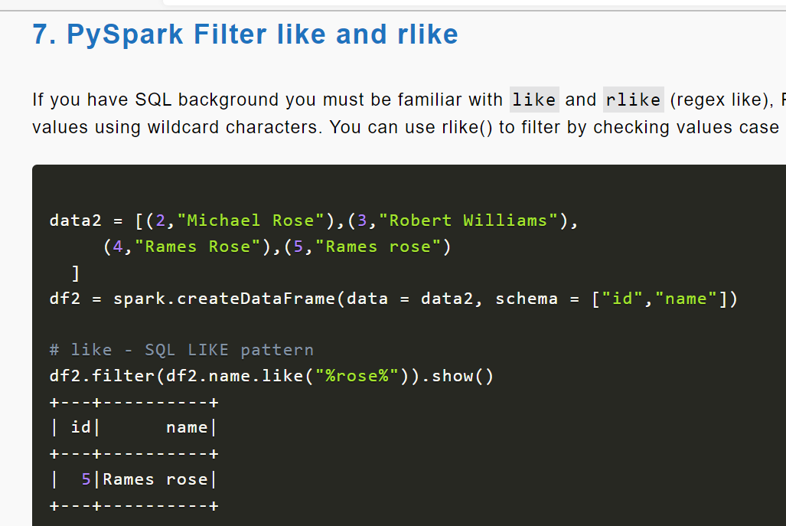

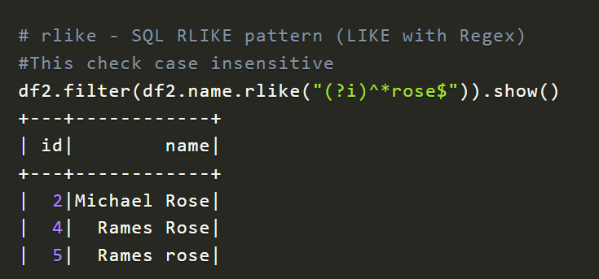

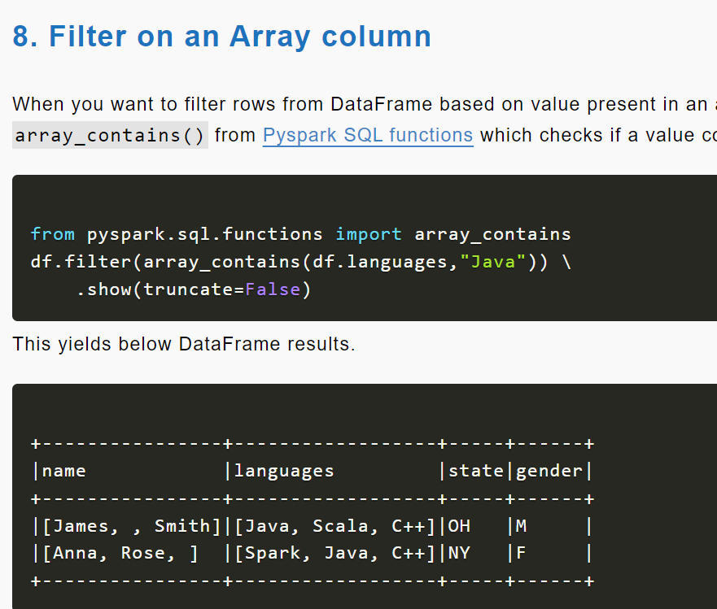

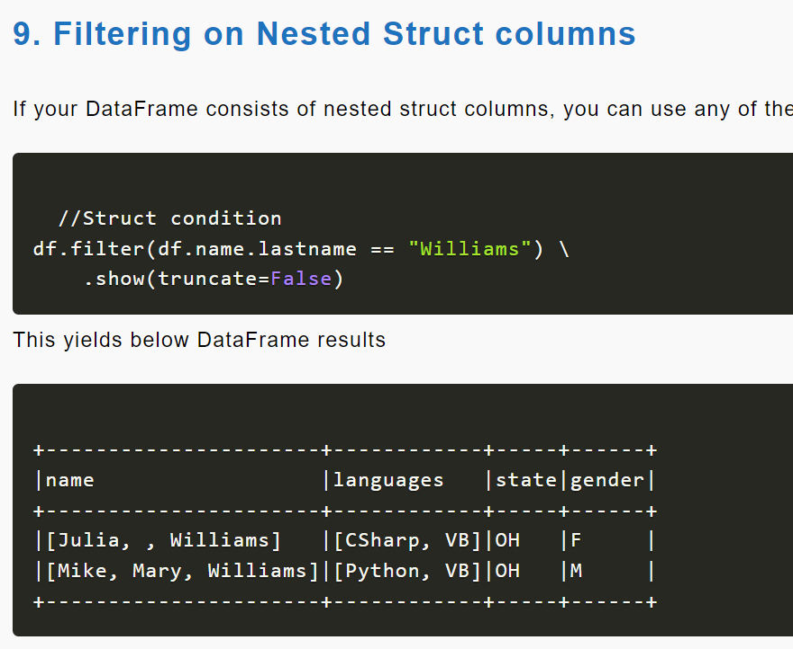

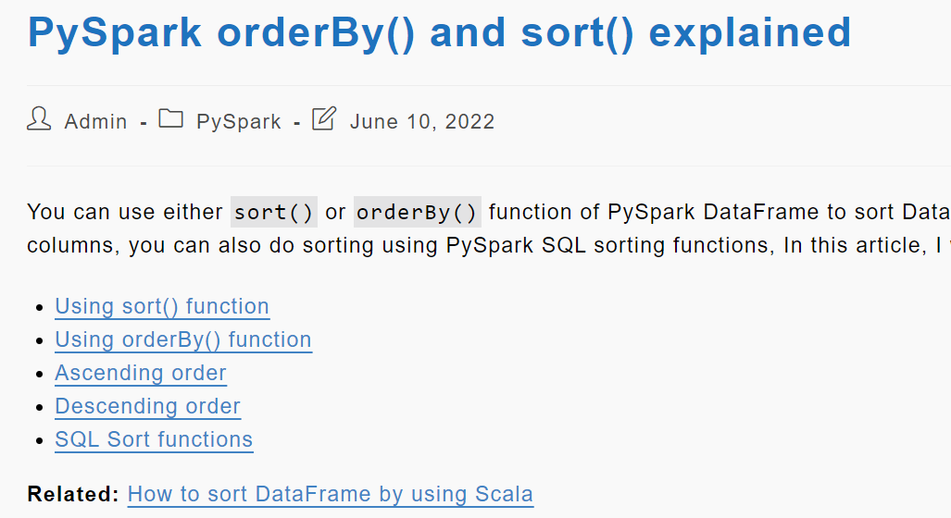

Sort()

Bydefault: ascending order

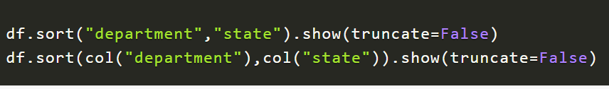

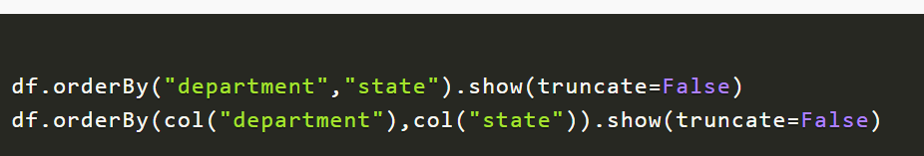

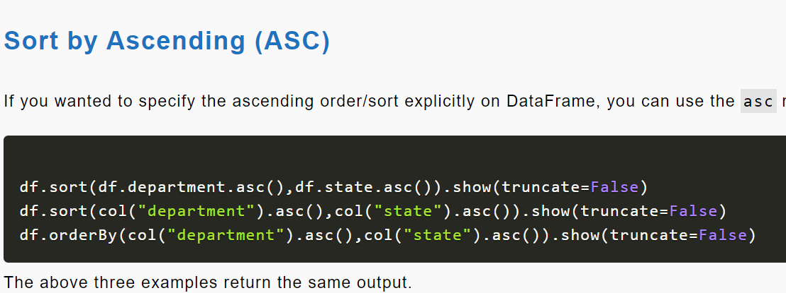

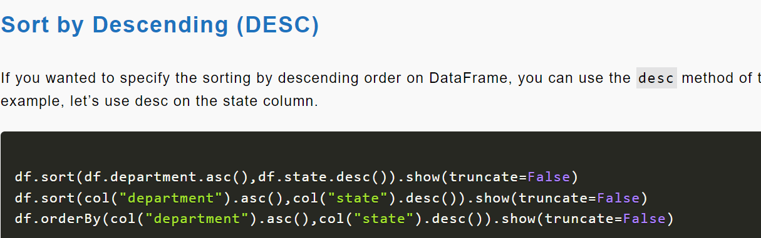

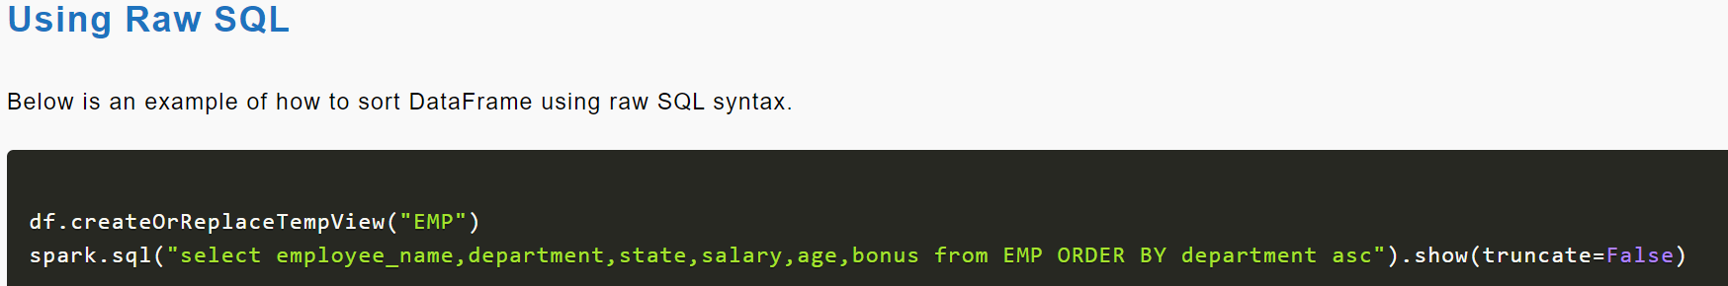

**PySpark Explode Array and Map Columns to Rows**

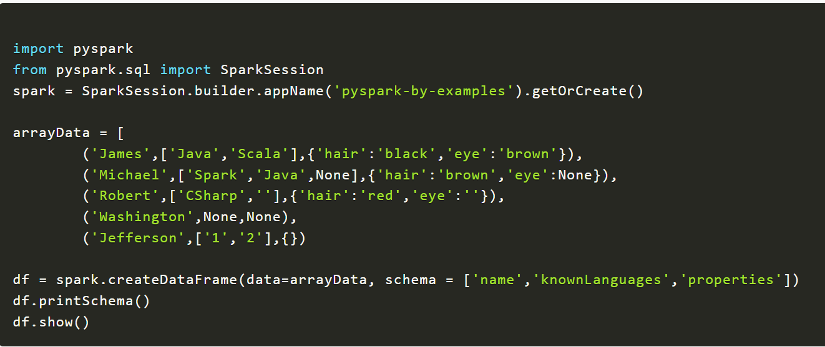

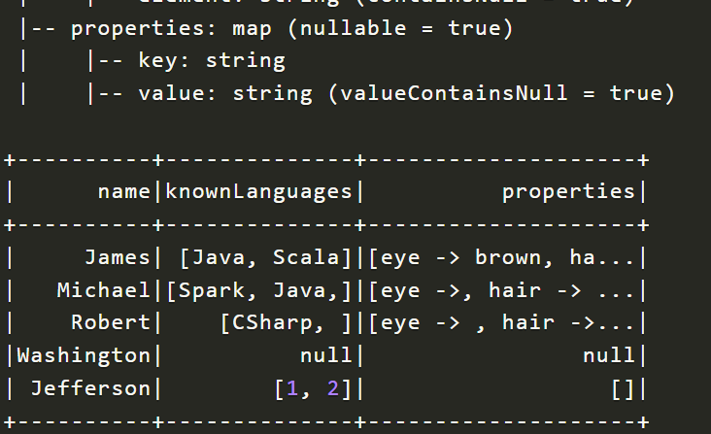

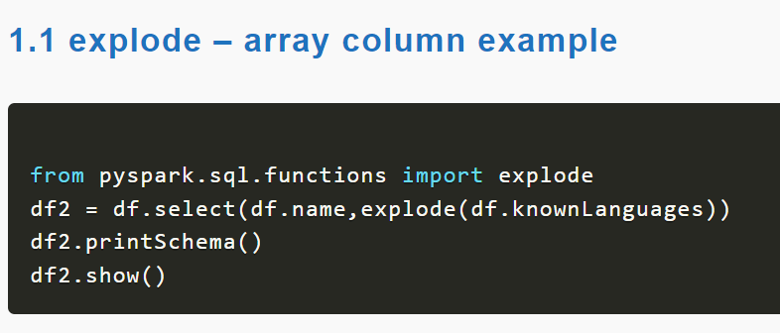

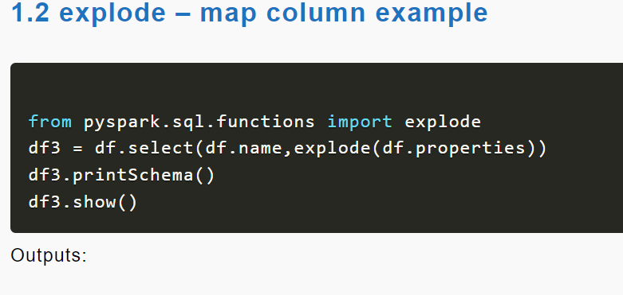

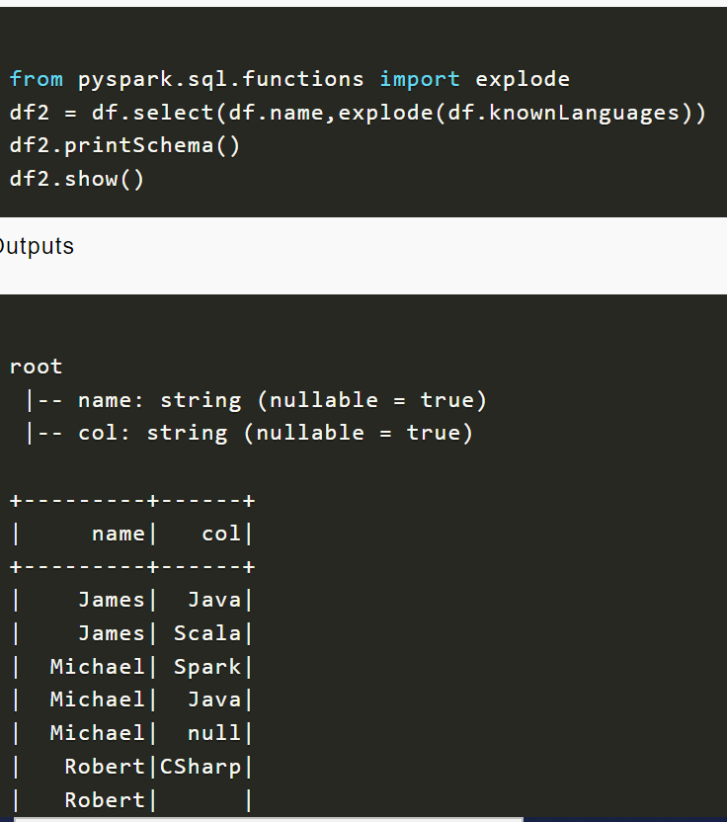

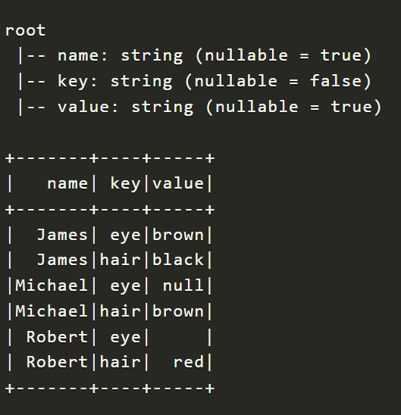

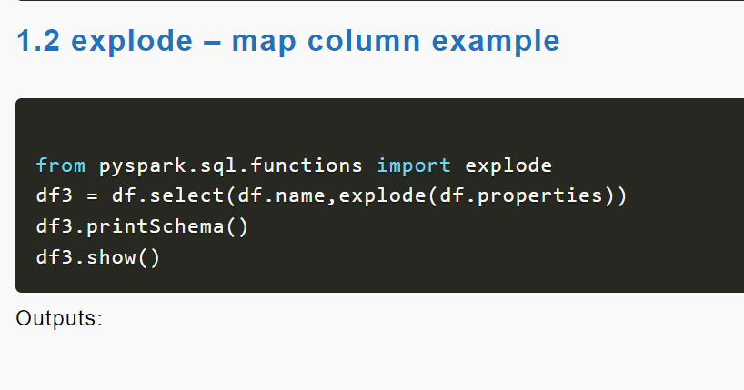

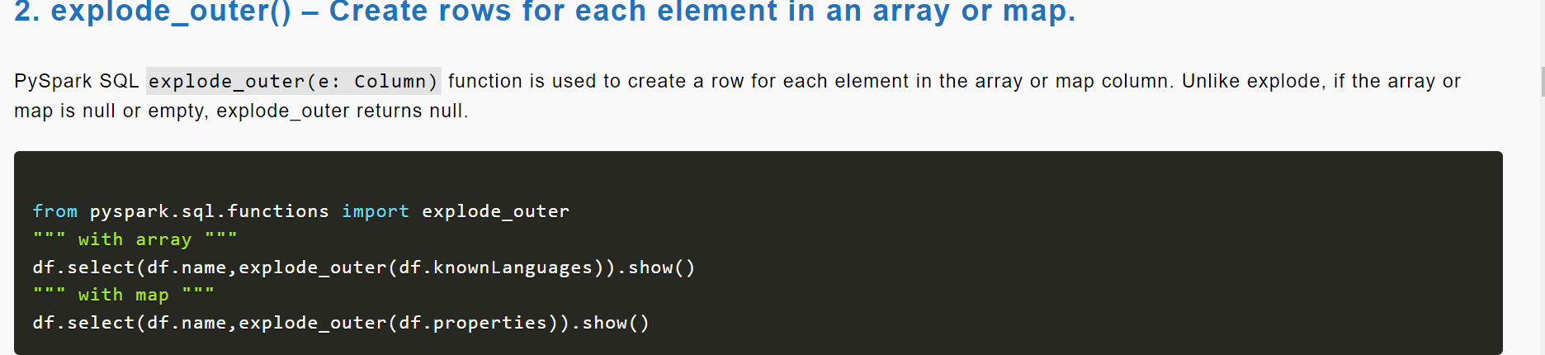

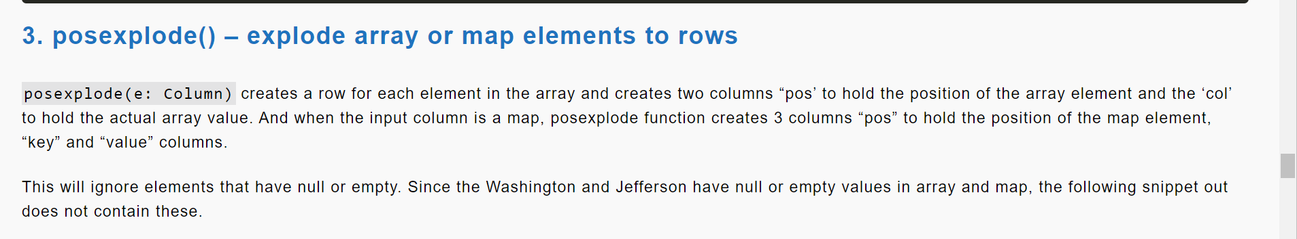

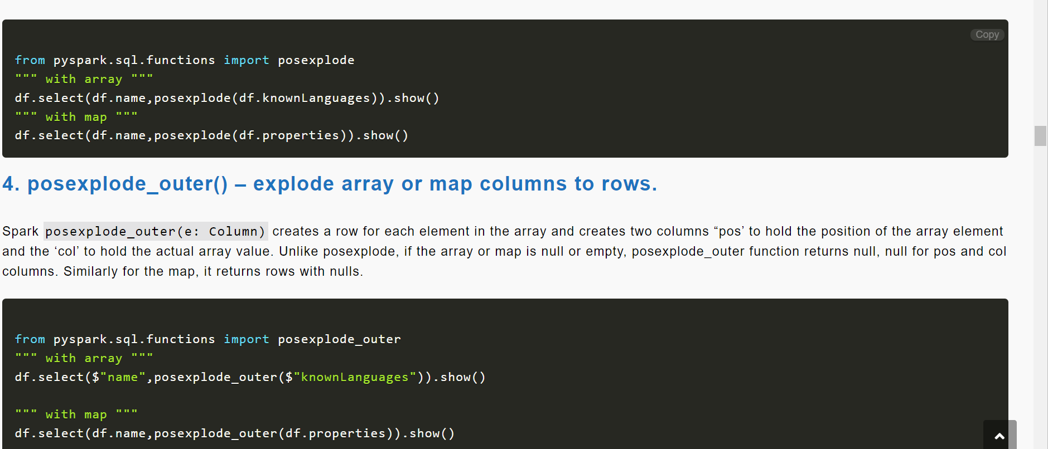

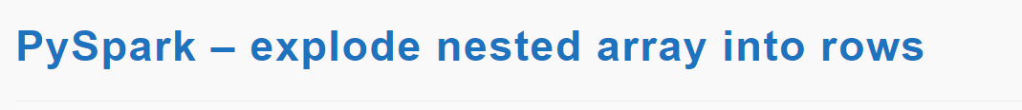

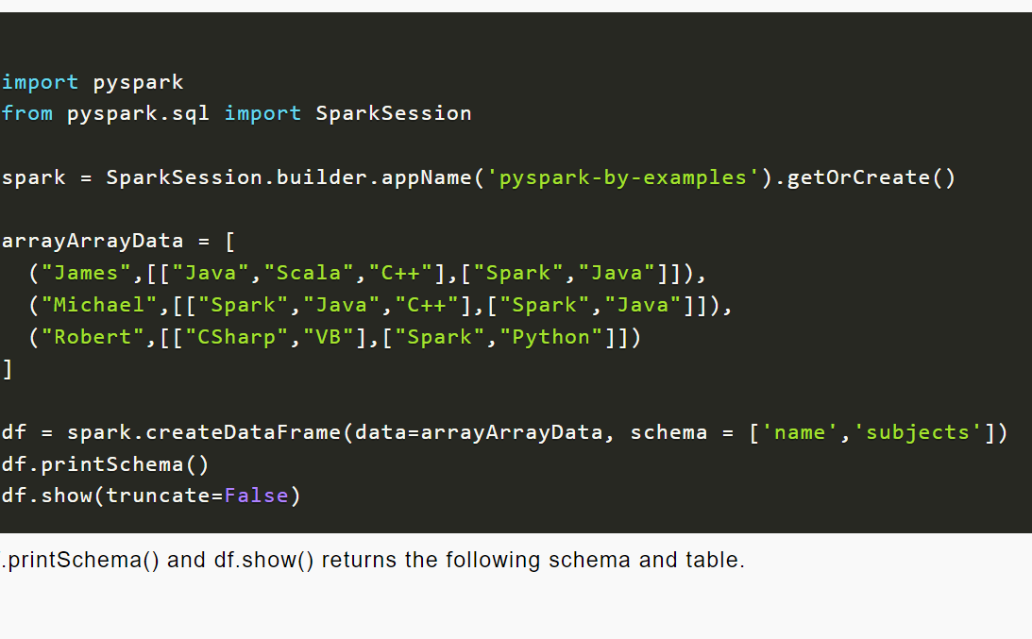

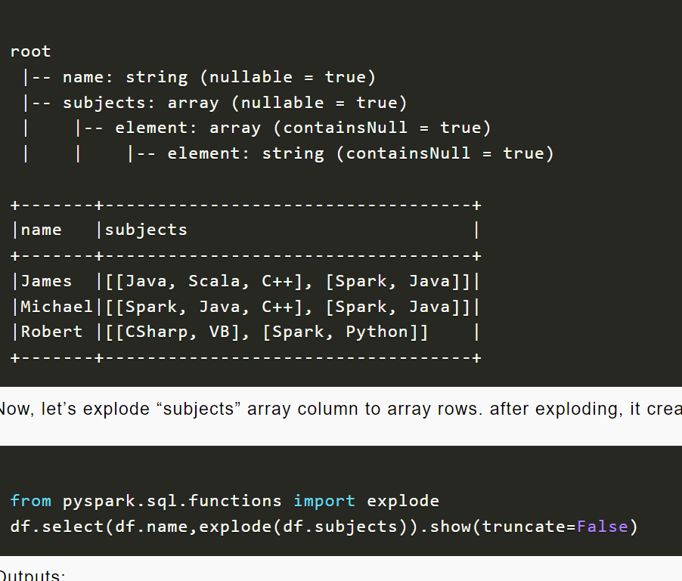

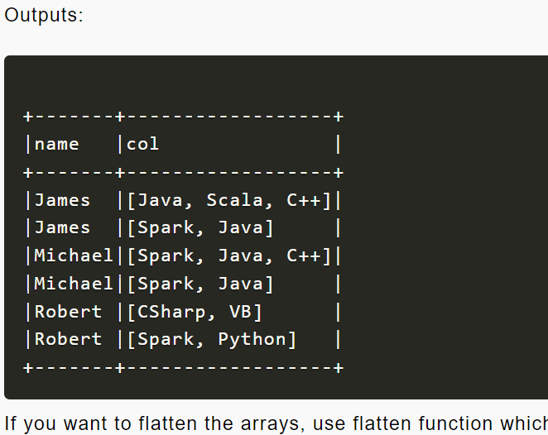

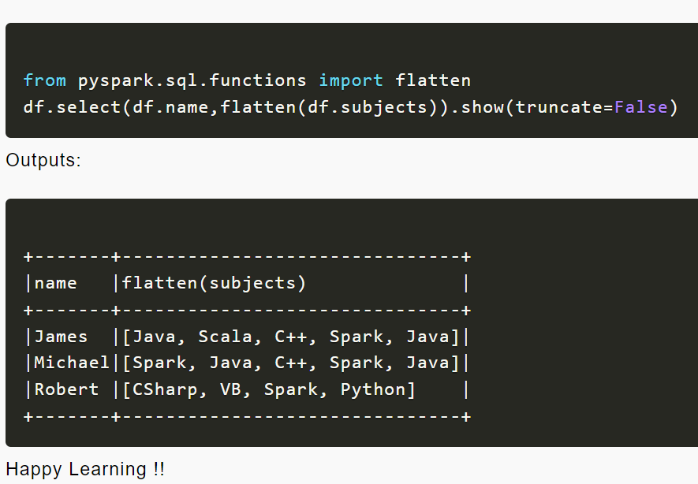

Groupby

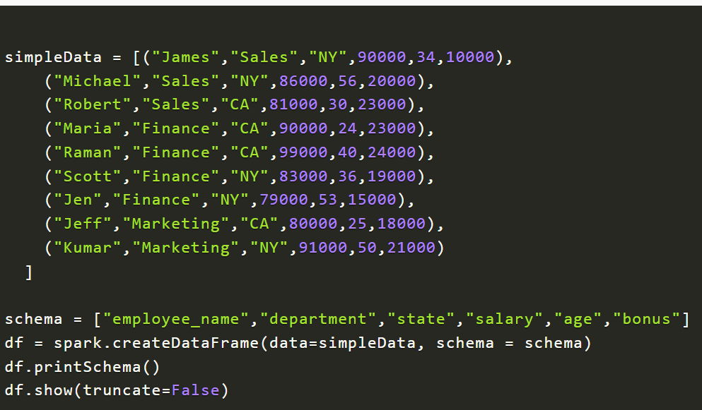

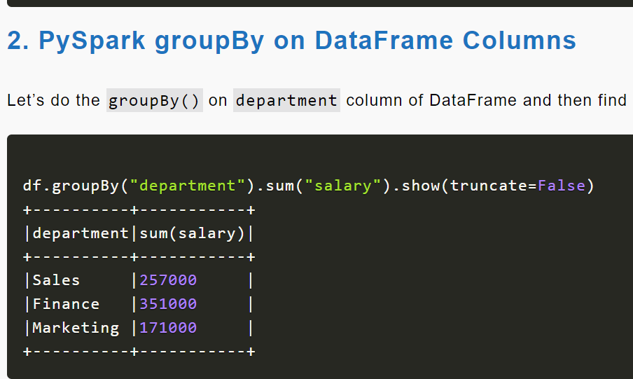

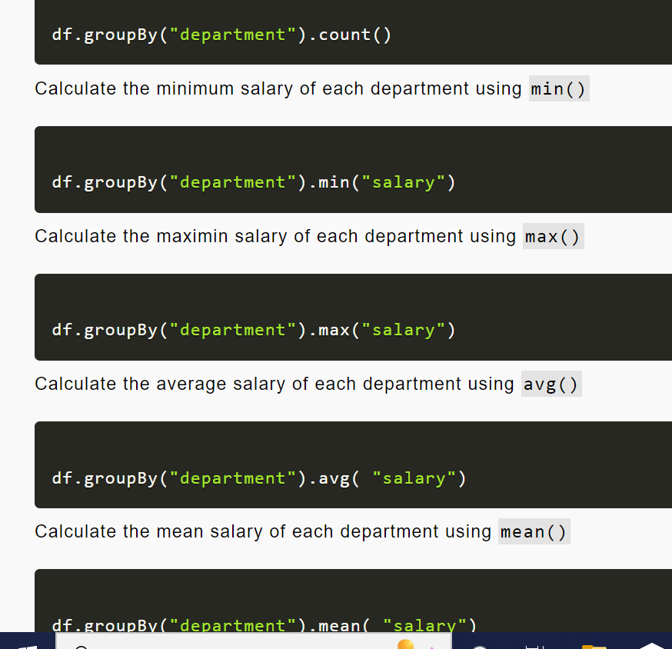

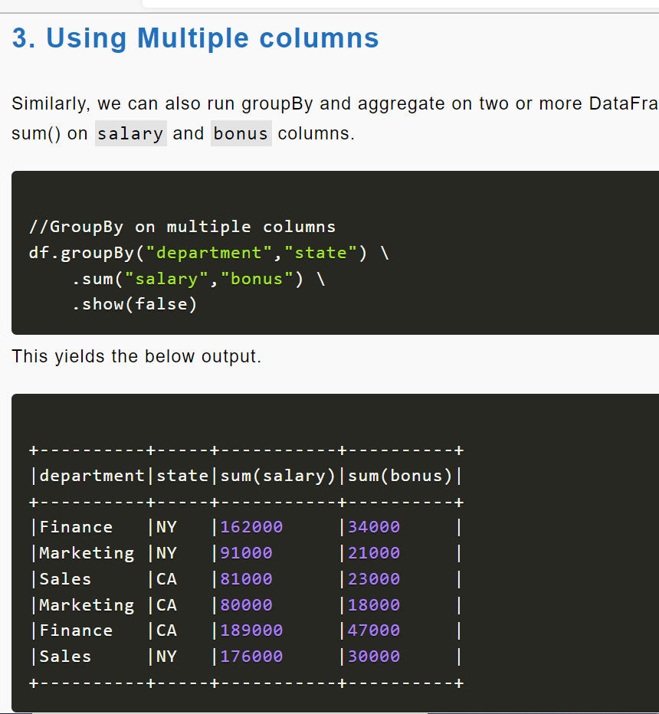

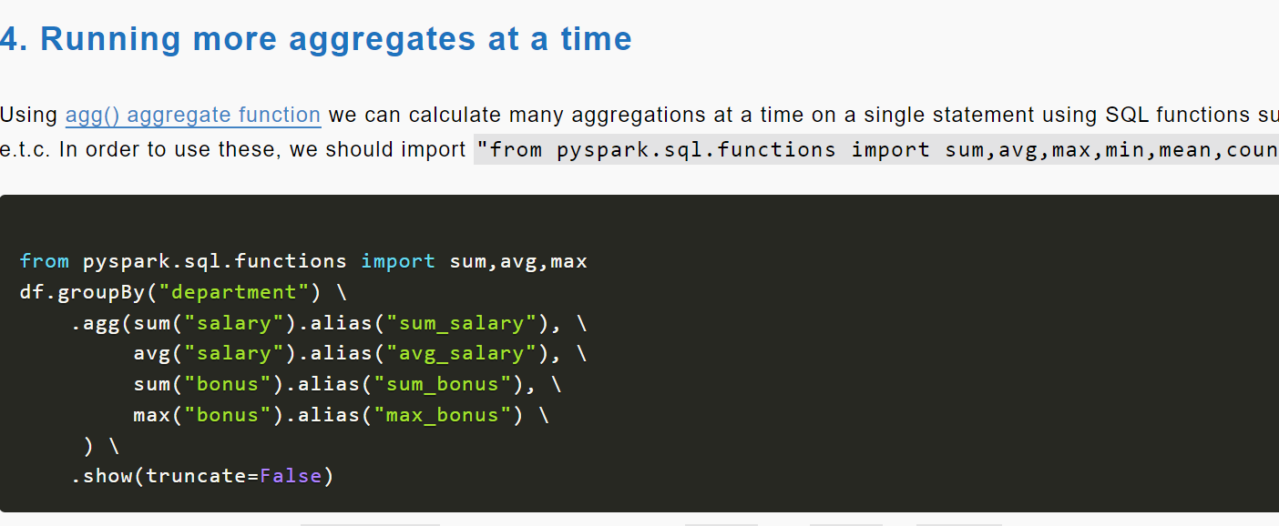

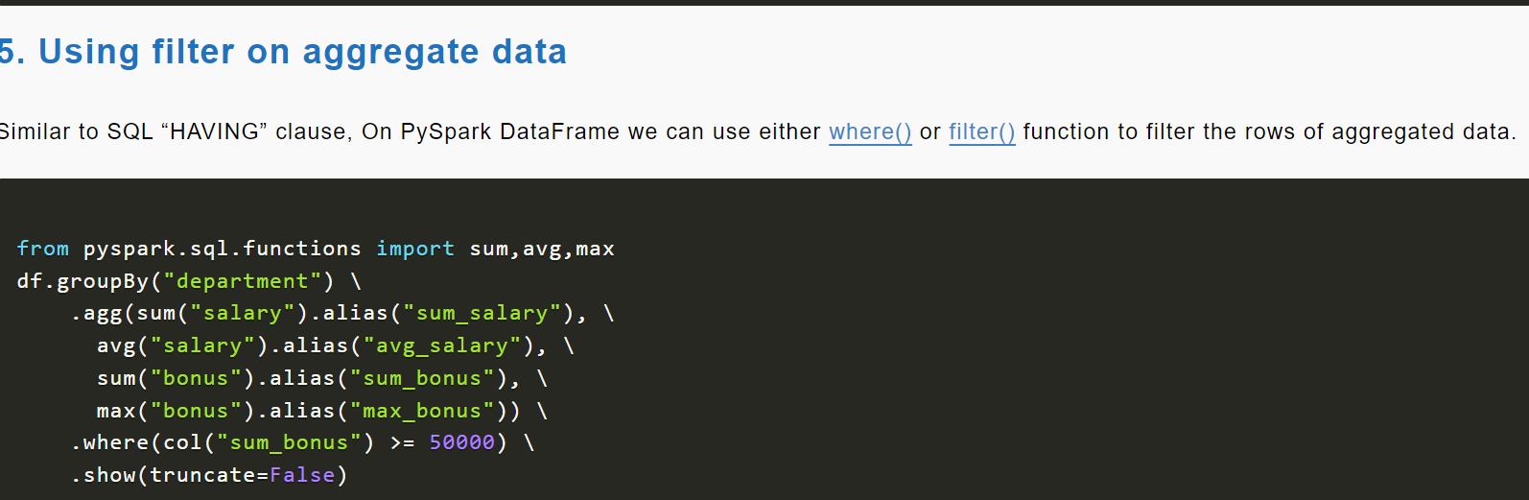

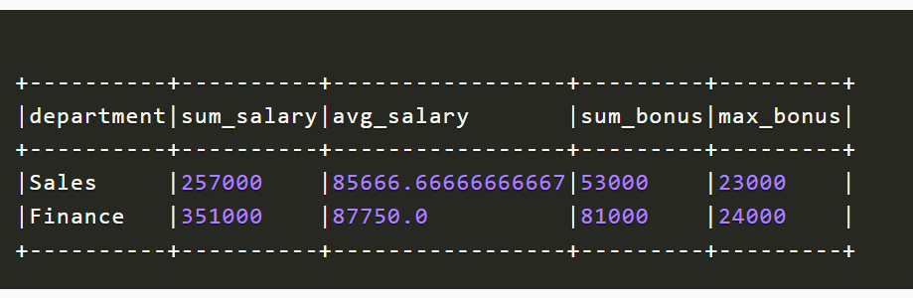

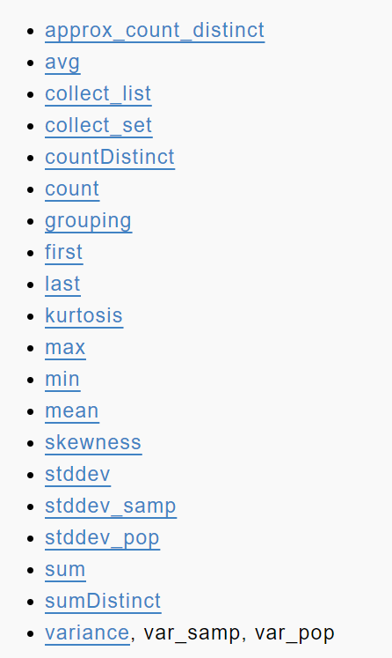

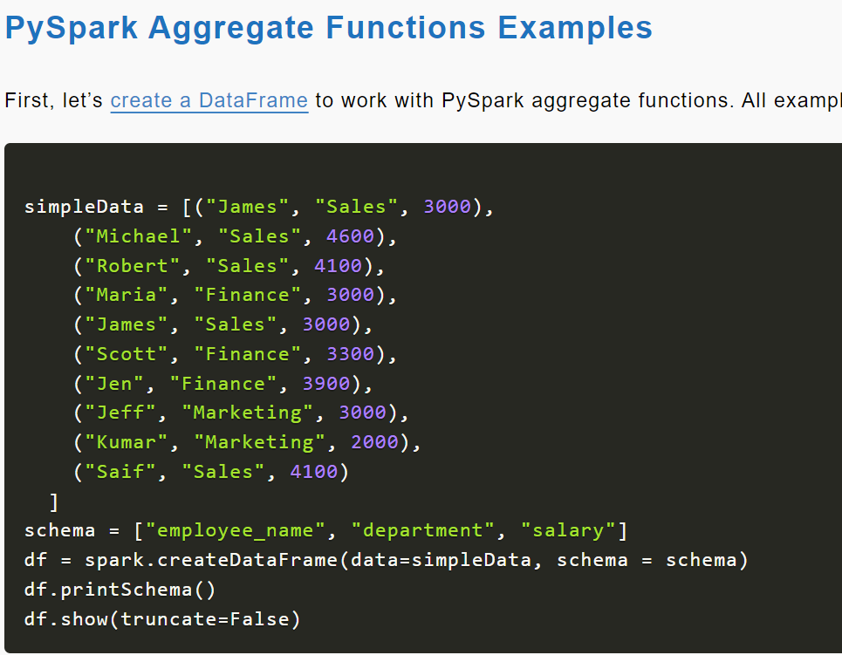

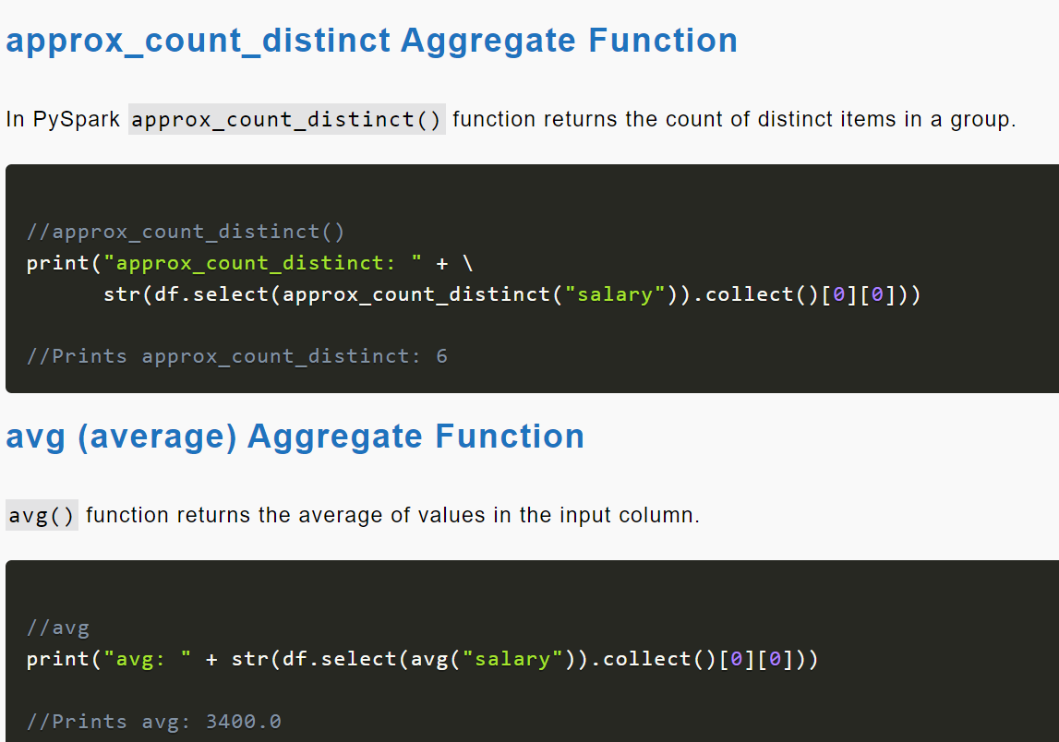

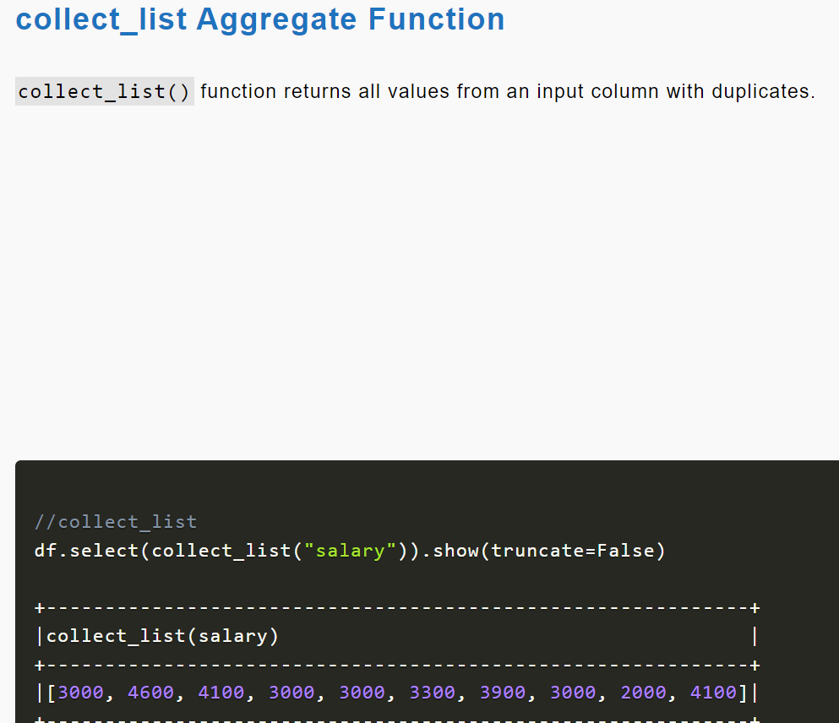

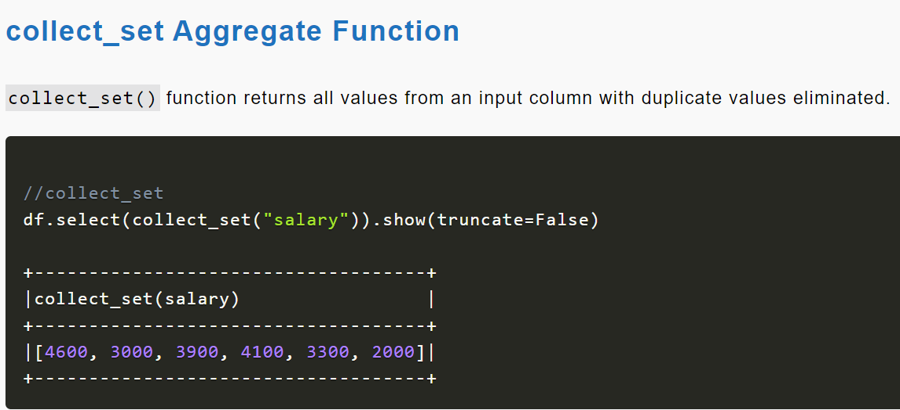

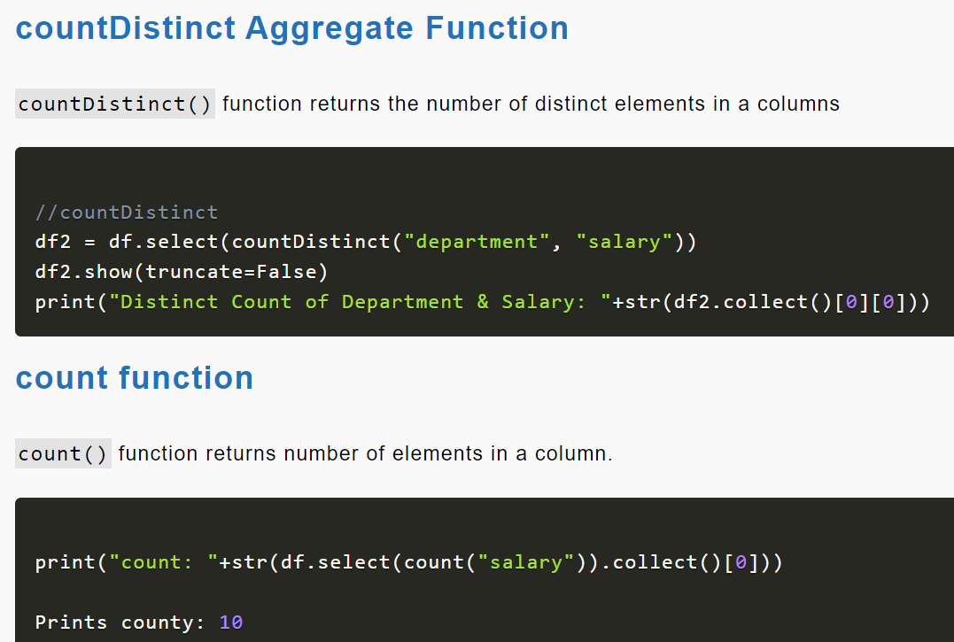

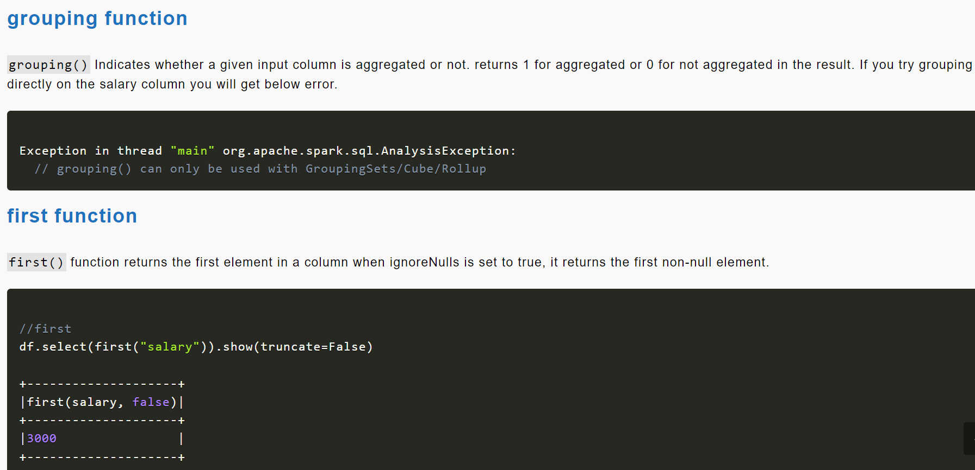

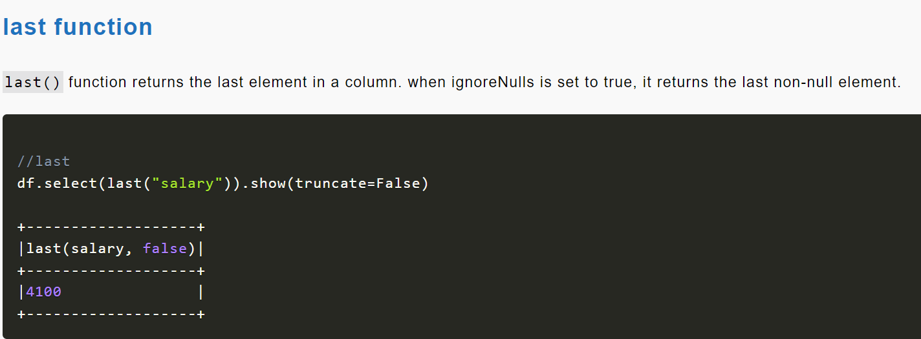

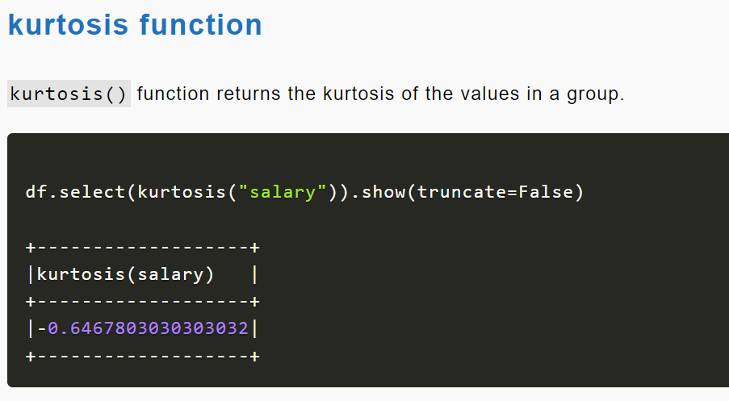

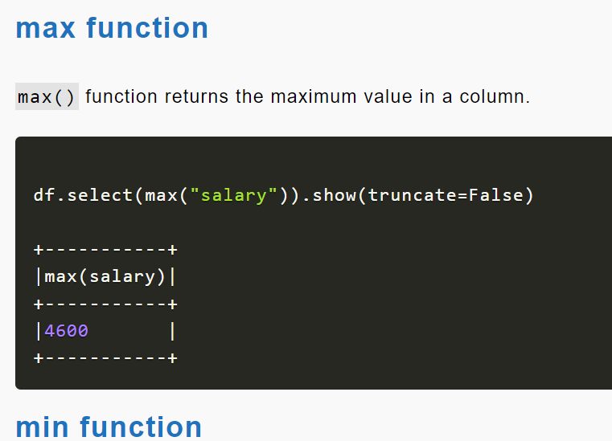

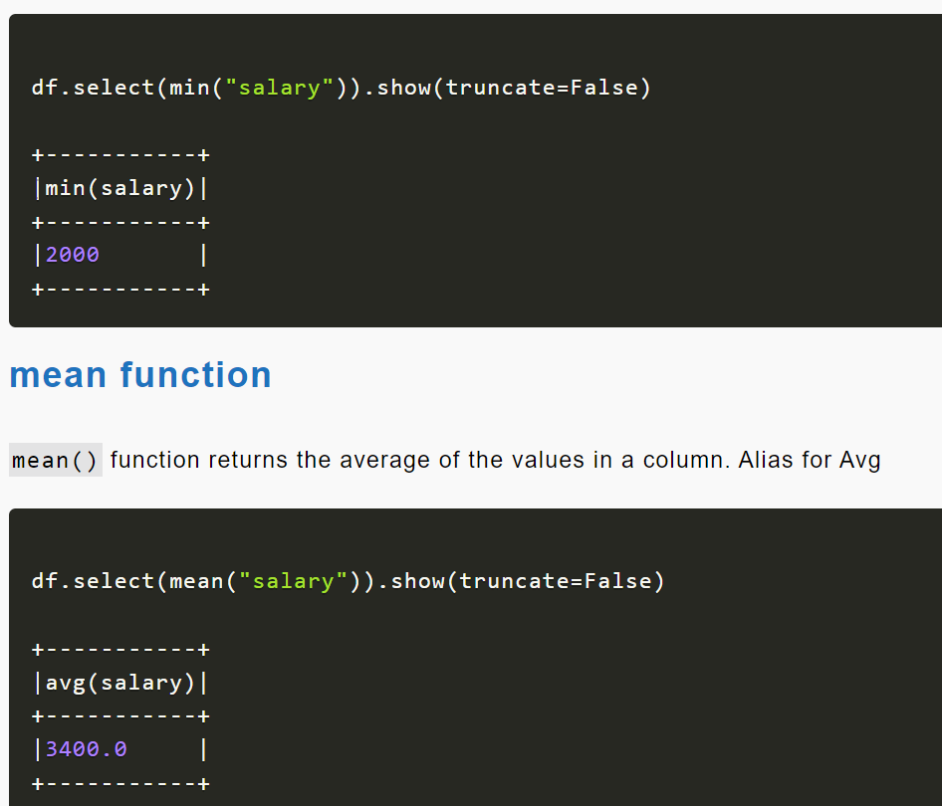

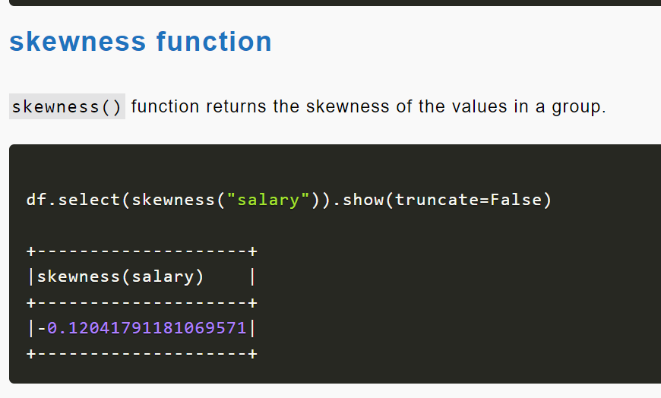

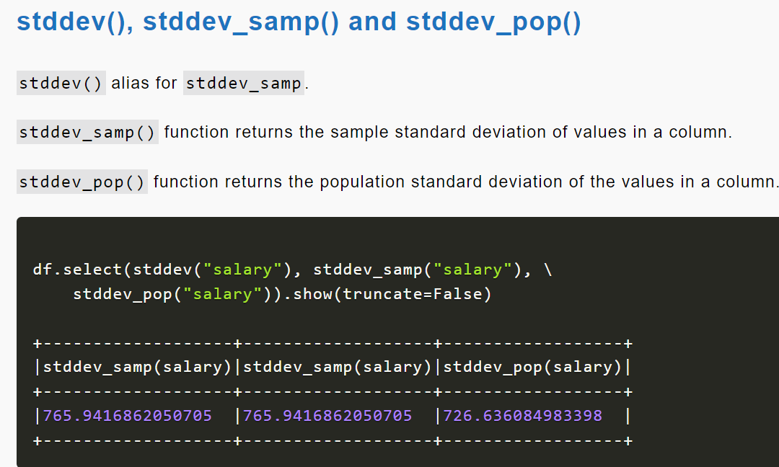

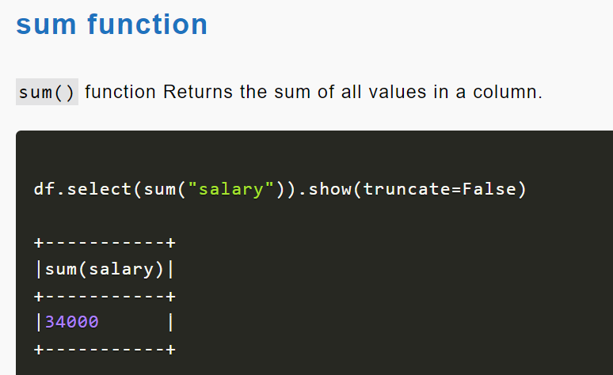

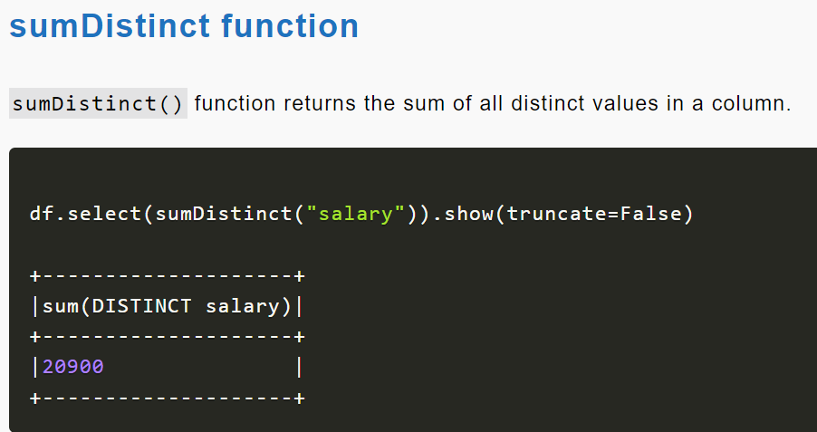

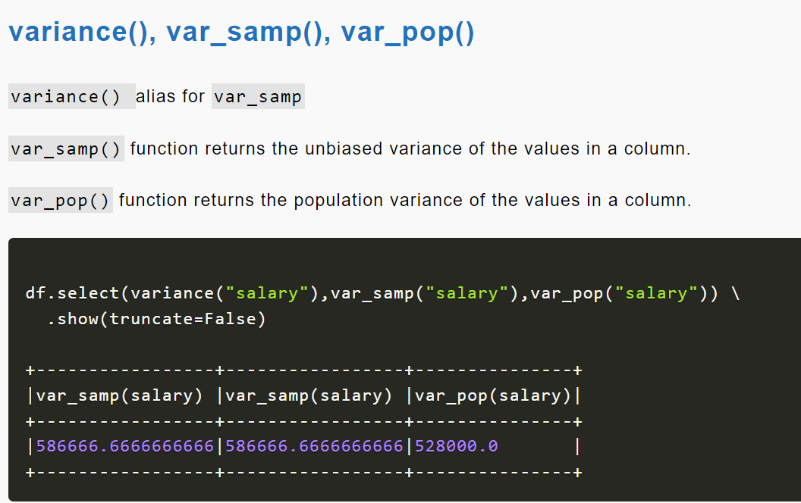

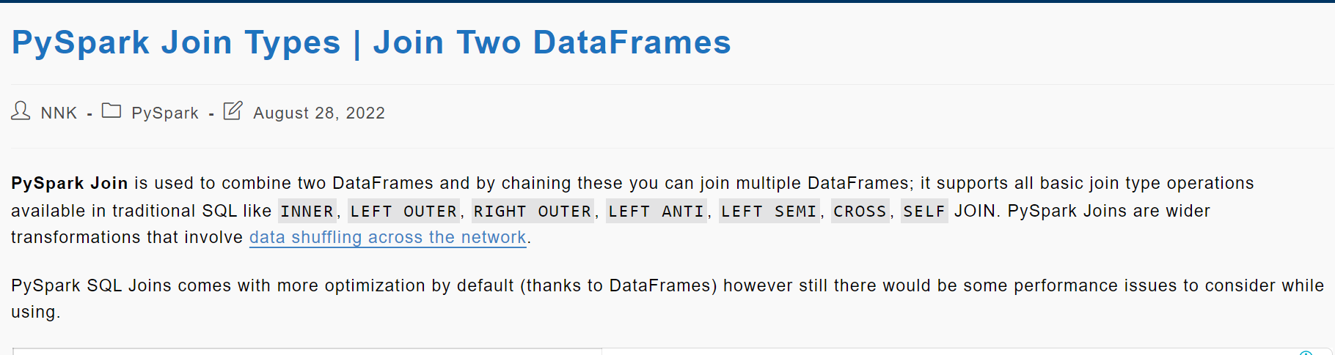

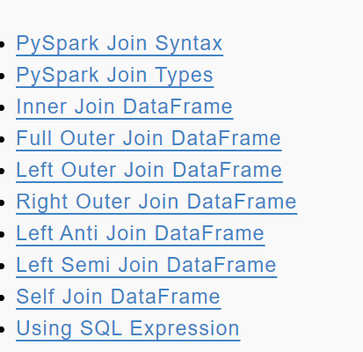

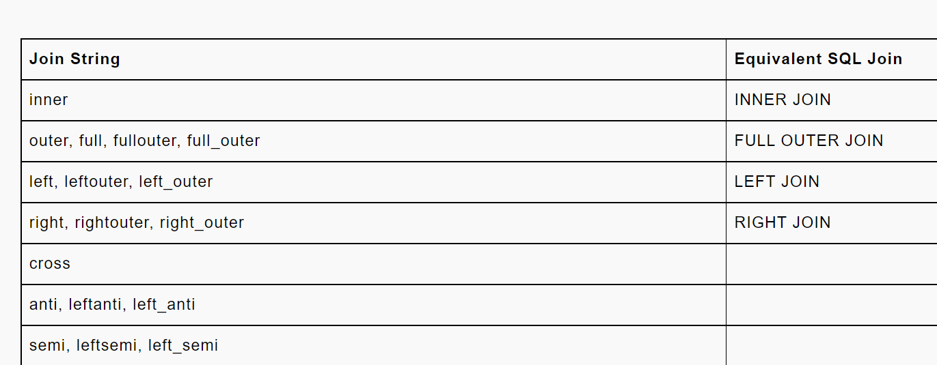

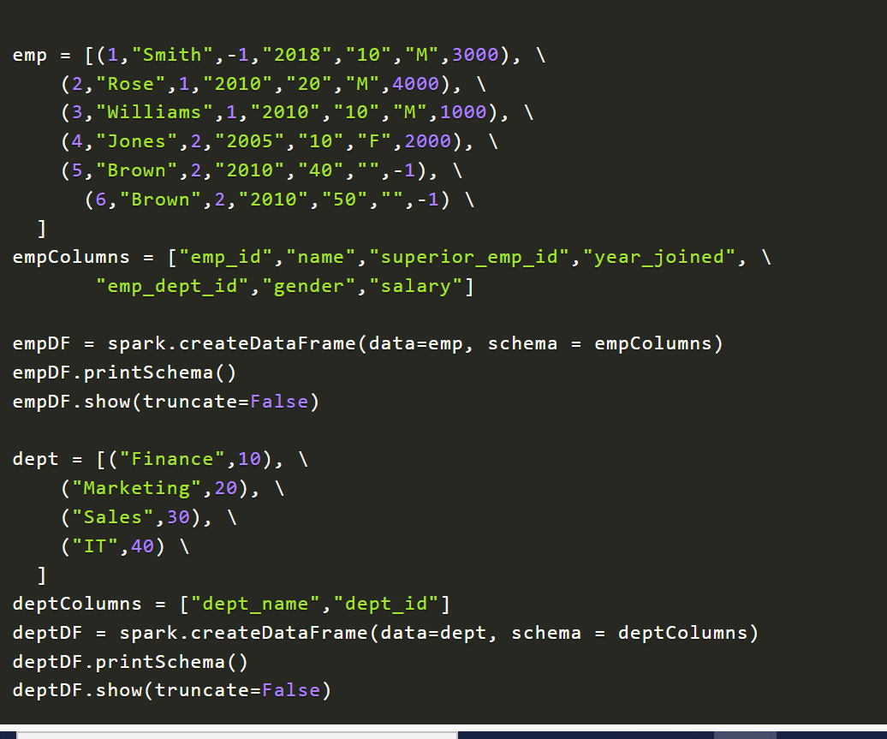

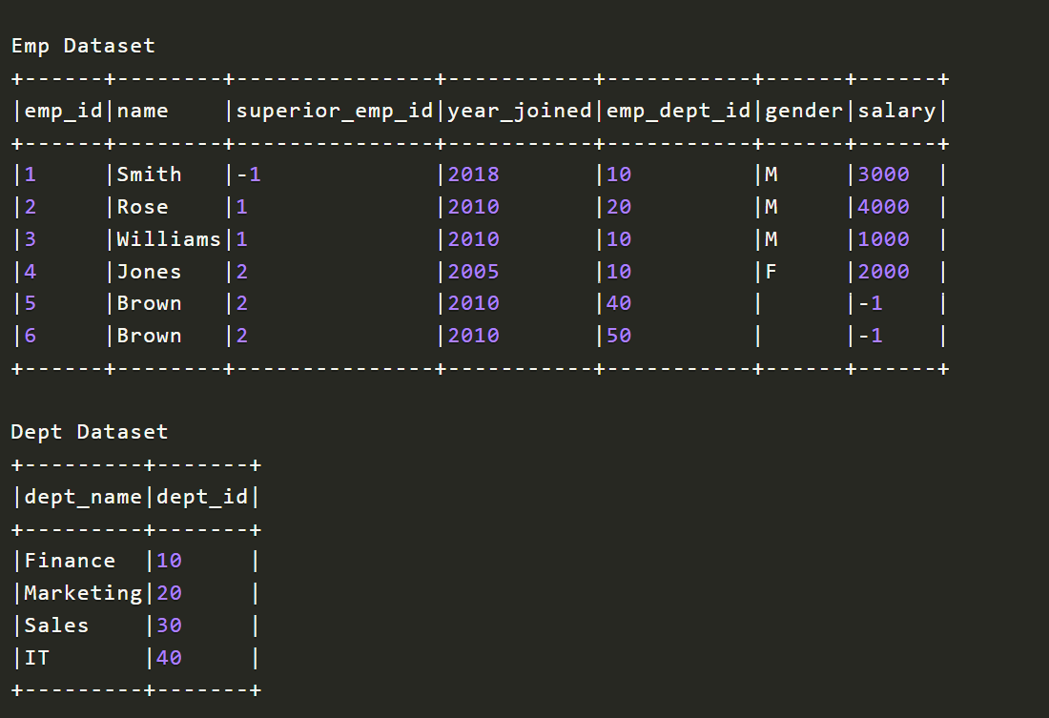

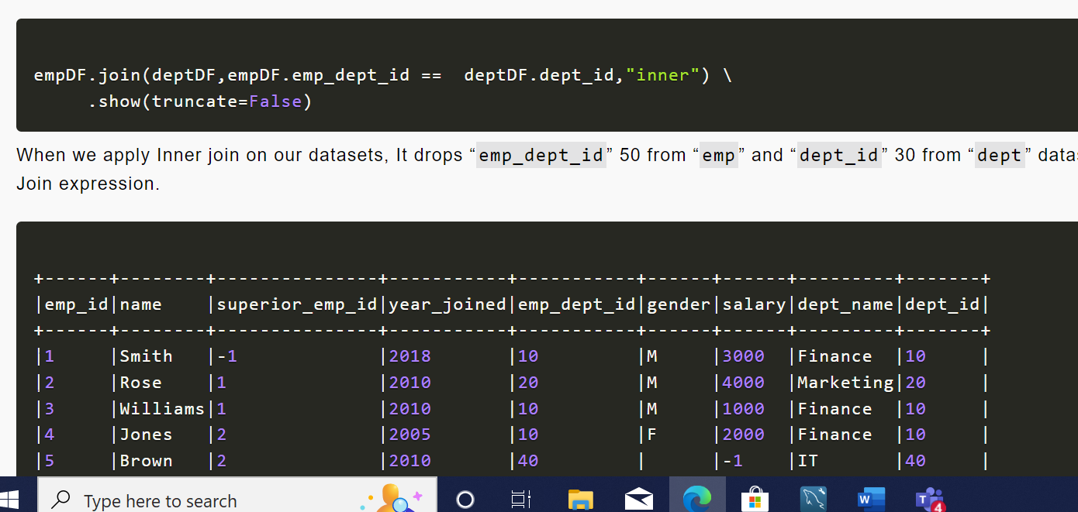

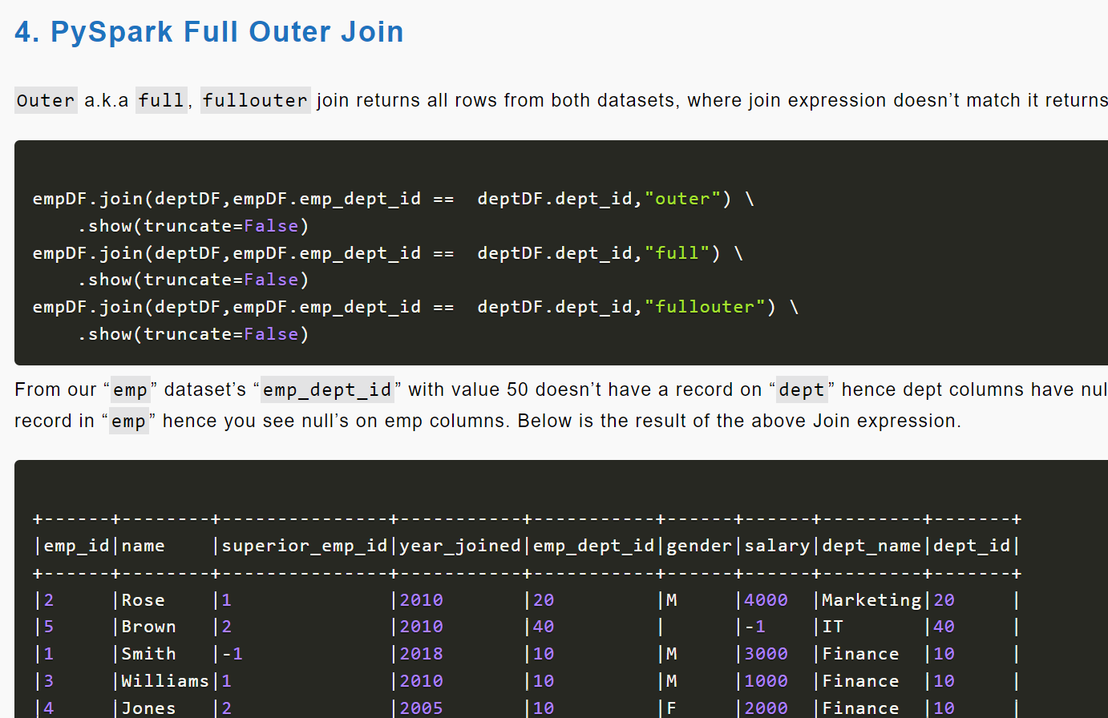

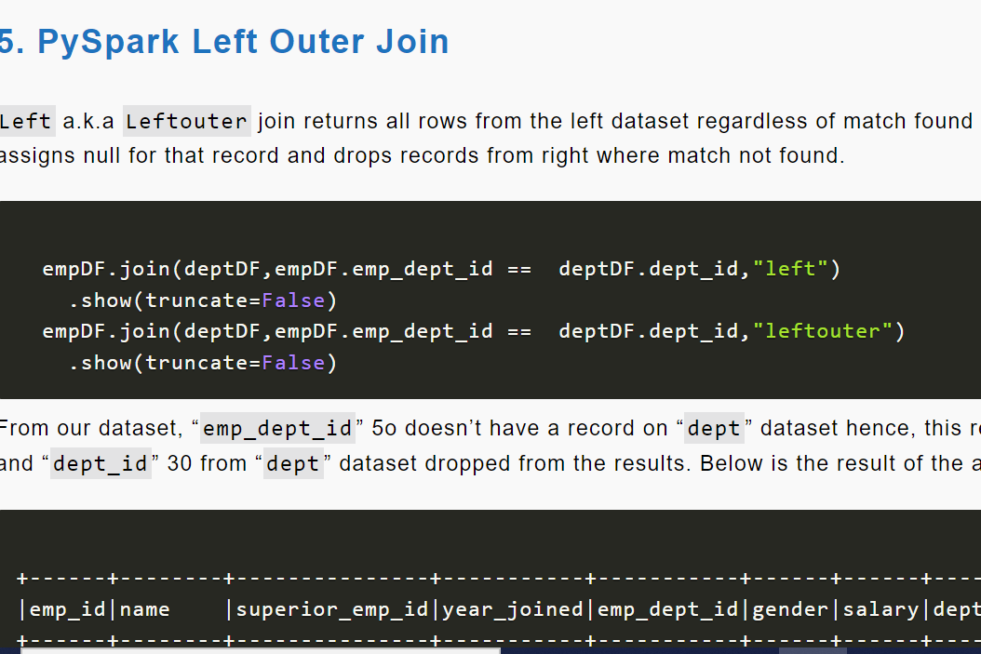

**Left Semi Join**

leftsemi join is similar to inner join difference being leftsemi join **returns all columns from the left dataset and ignores all columns from the right dataset. In other words**, this join returns columns from the only left dataset for the records match in the right dataset on join expression, records not matched on join expression are ignored from both left and right datasets.

The same result can be achieved using select on the result of the inner join however, using this join would be efficien

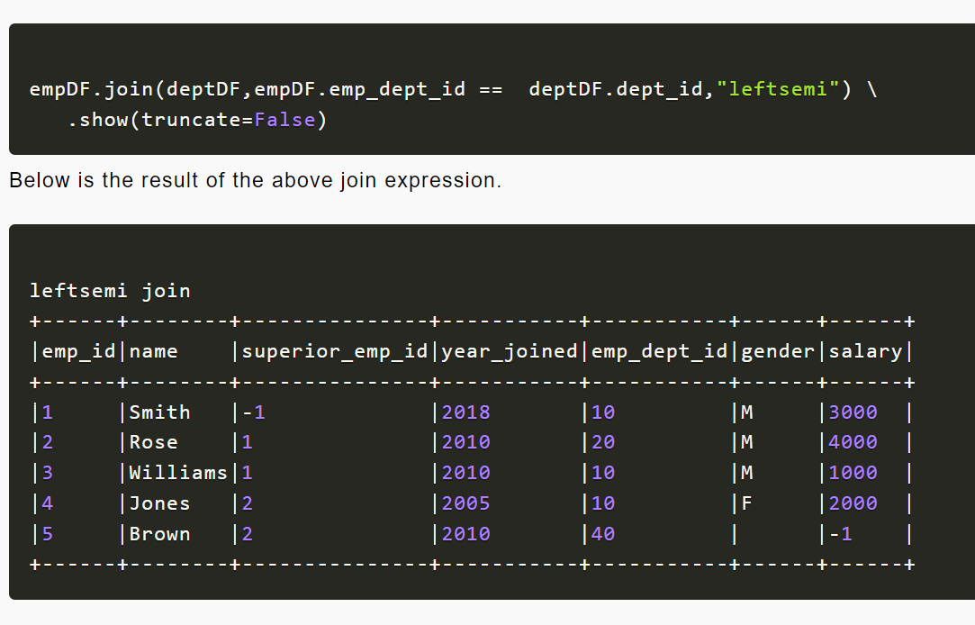

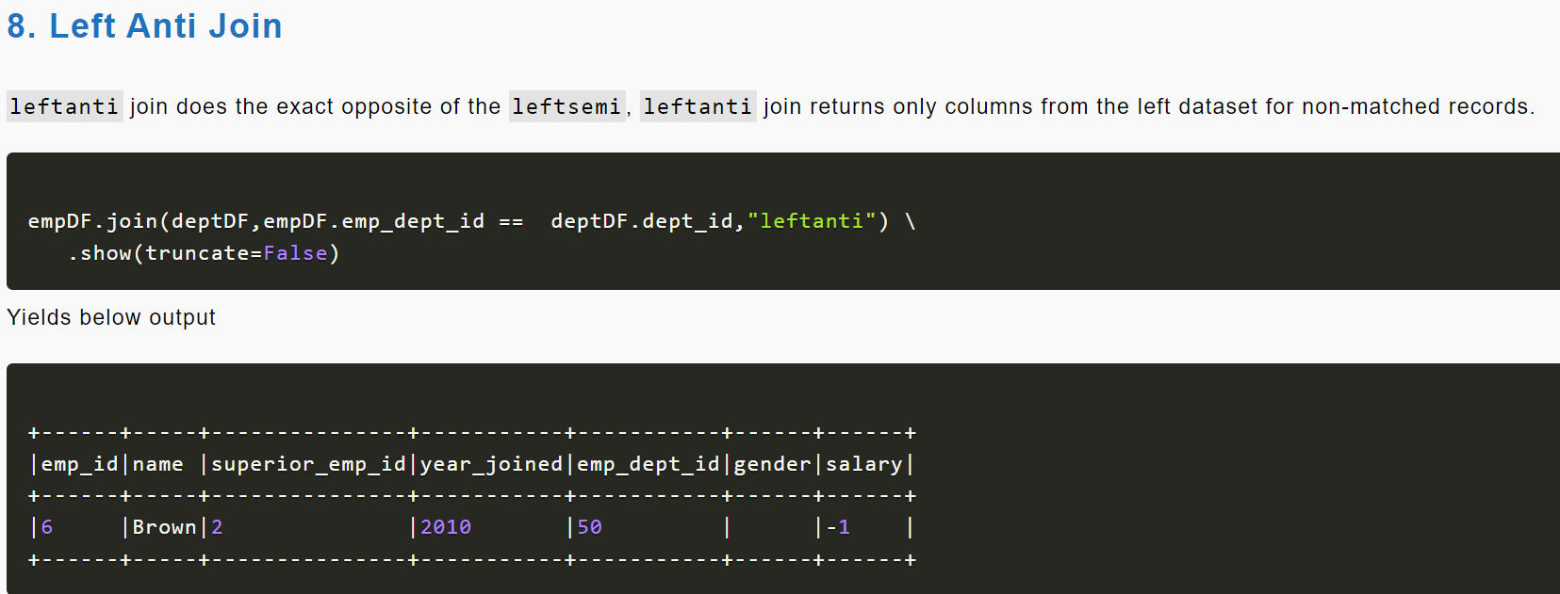

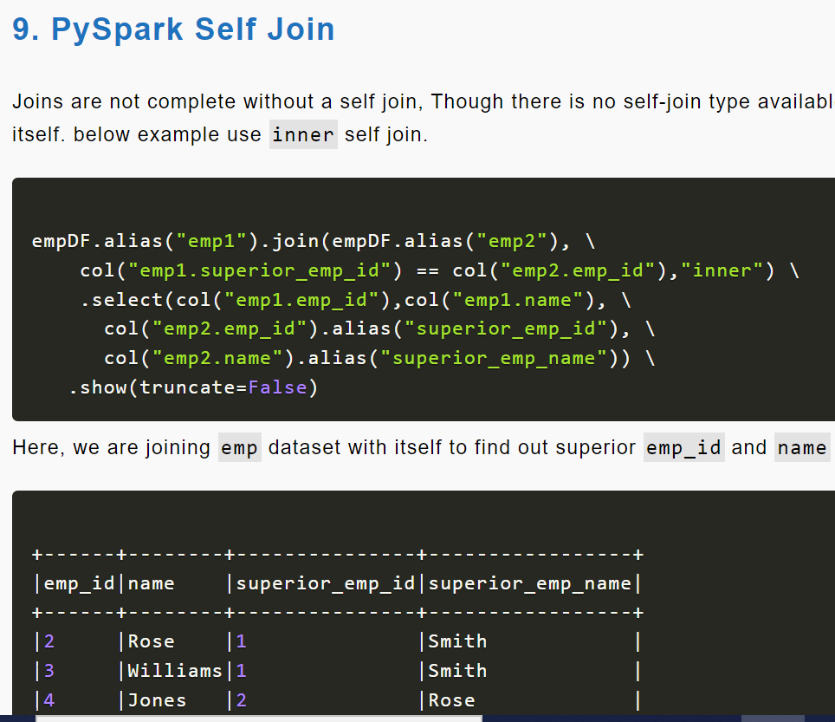

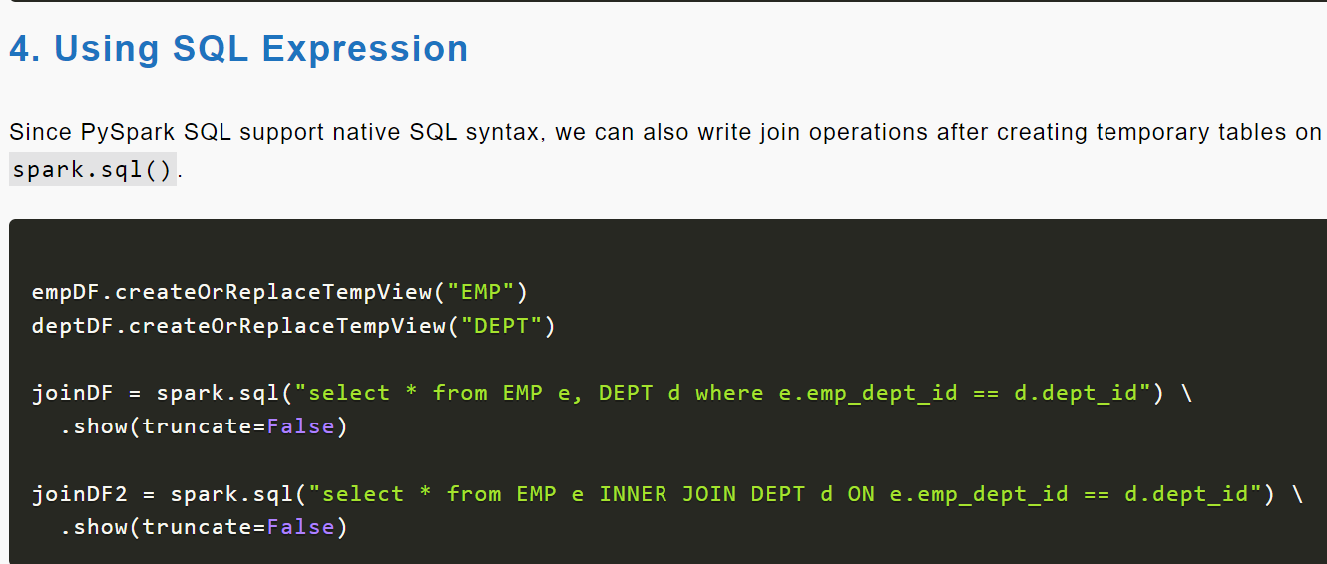

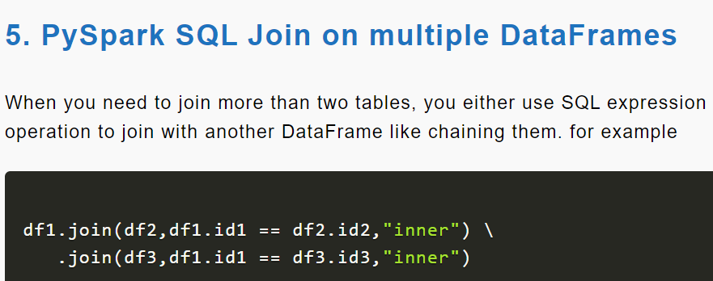

**PySpark SQL Tutorial**

PySpark SQL is one of the most used Py**Spark** modules which is used for processing structured columnar data format.

Once you have a DataFrame created, you can interact with the data by using SQL syntax.

In other words, Spark SQL brings native RAW SQL queries on Spark meaning you can run traditional ANSI SQL’s on Spark Dataframe, in the later section of this PySpark SQL tutorial, you will learn in detail using SQL select, where, group by, join, union e.t.c

How to work with sql

n order to use SQL, first, create a temporary table on DataFrame using createOrReplaceTempView() function.

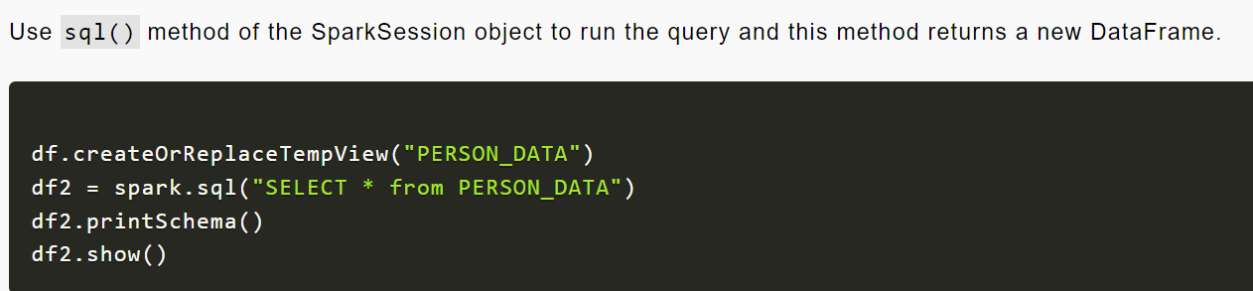

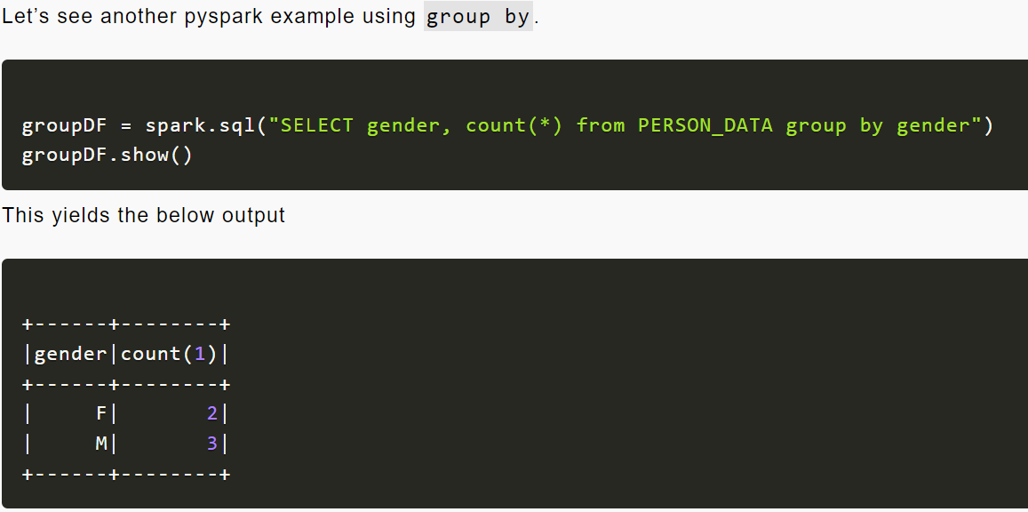

**PySpark Streaming Tutorial**

PySpark Streaming is a scalable, high-throughput, fault-tolerant streaming processing system that supports both batch and streaming workloads. It is used to process real-time data from sources like file system folder, TCP socket, [S3](https://aws.amazon.com/s3/), [Kafka](https://kafka.apache.org/), [Flume](https://en.wikipedia.org/wiki/Apache_Flume), [Twitter](https://developer.twitter.com/en/docs/tutorials/consuming-streaming-data), and [Amazon Kinesis](https://aws.amazon.com/kinesis/) to name a few. The processed data can be pushed to databases, Kafka, live dashboards e.t.c

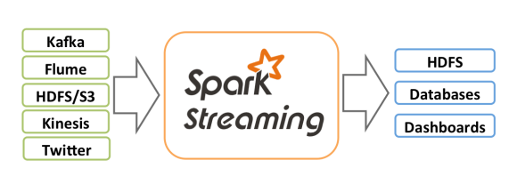source: <https://spark.apache.org/>

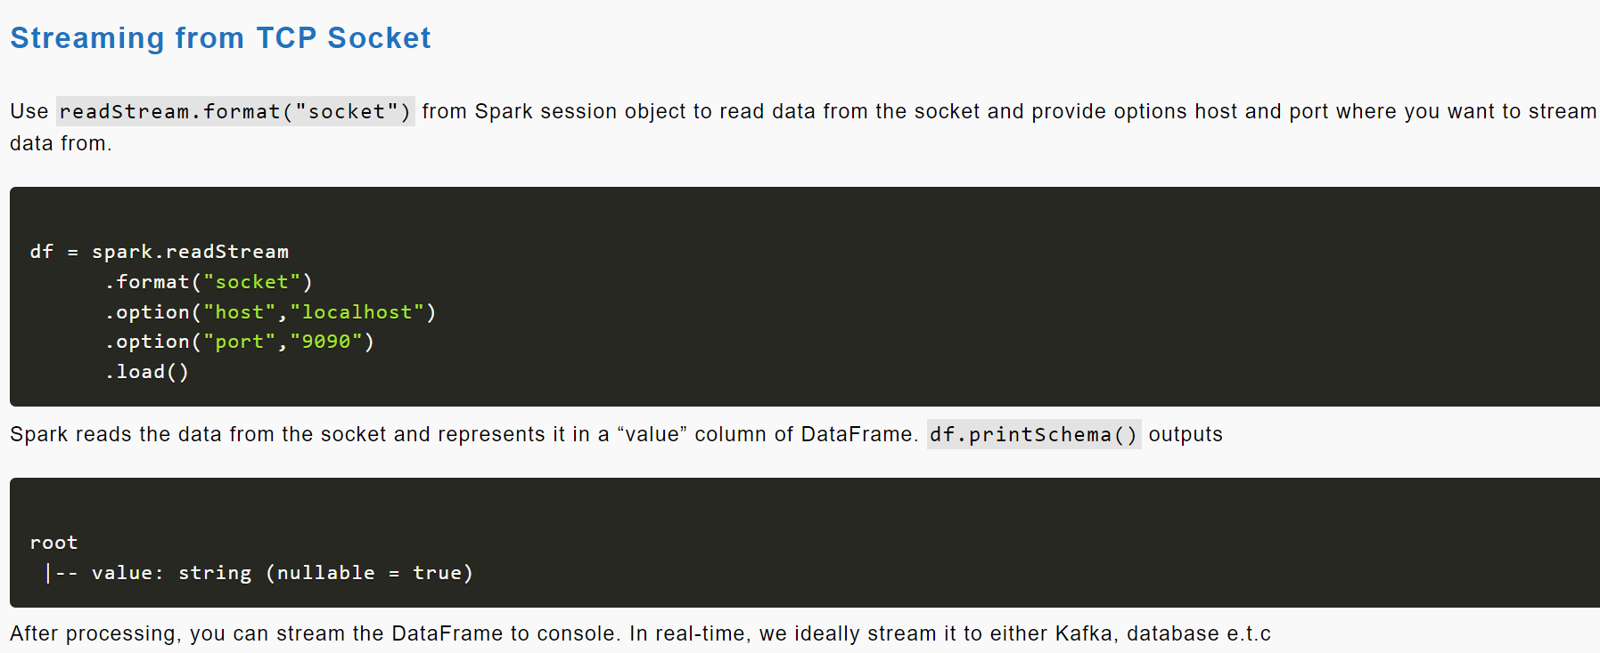

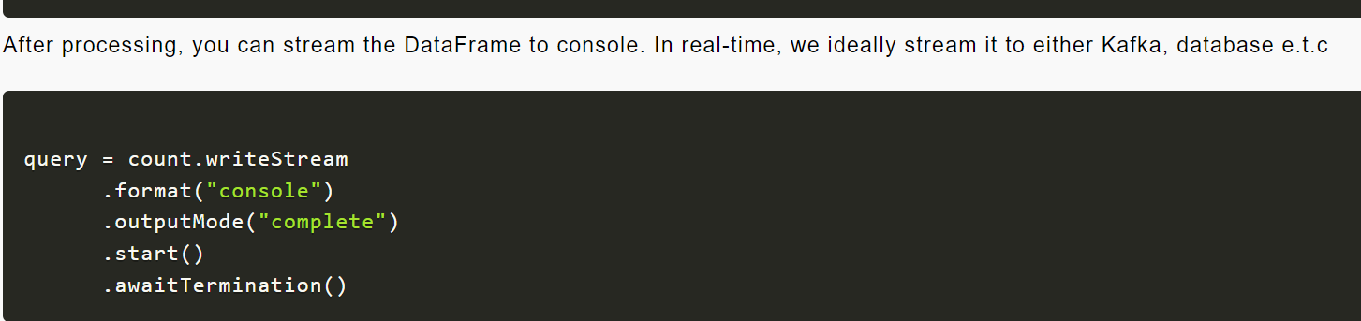

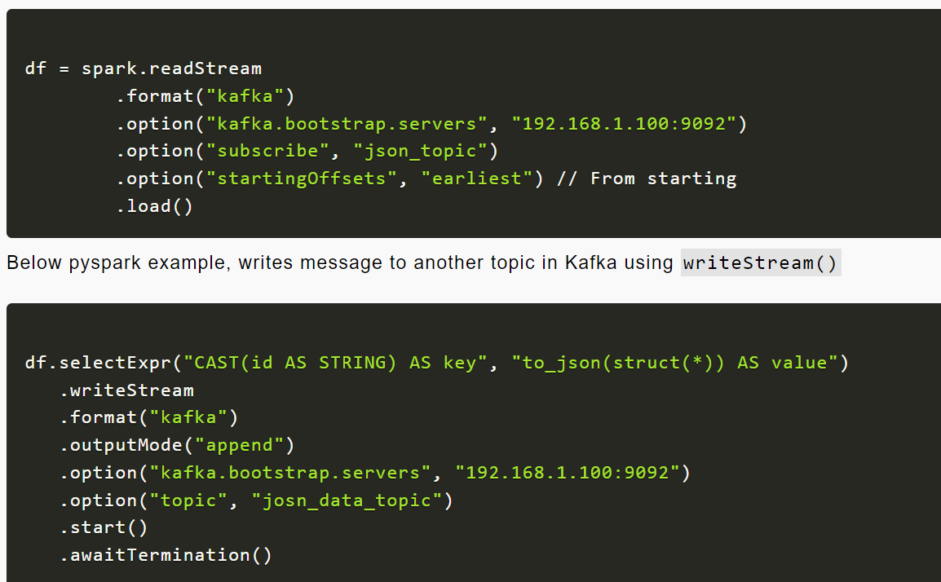

**PySpark Read CSV file into DataFrame**

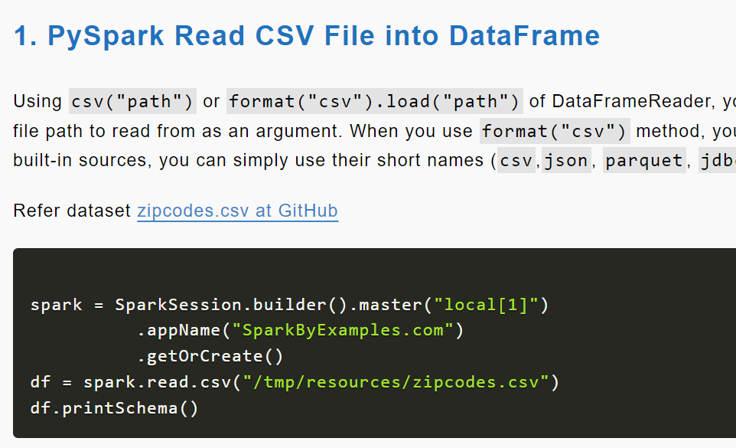

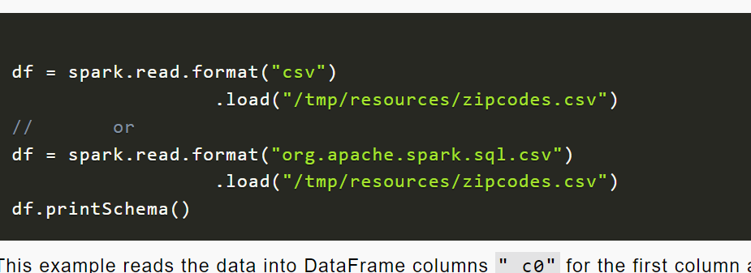

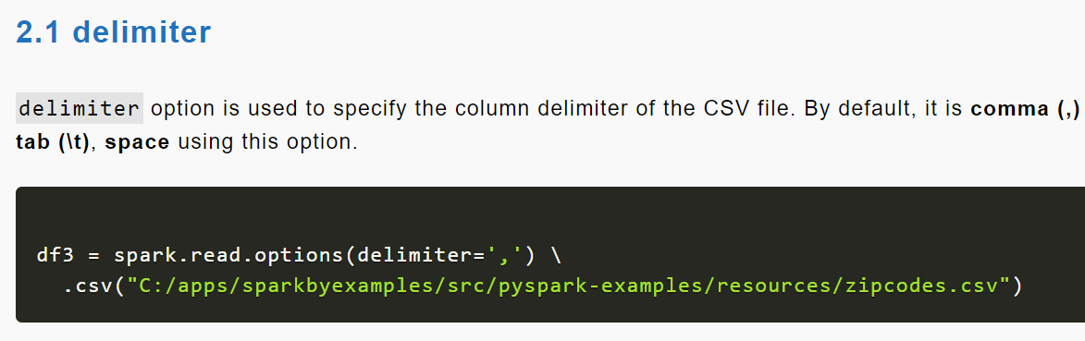

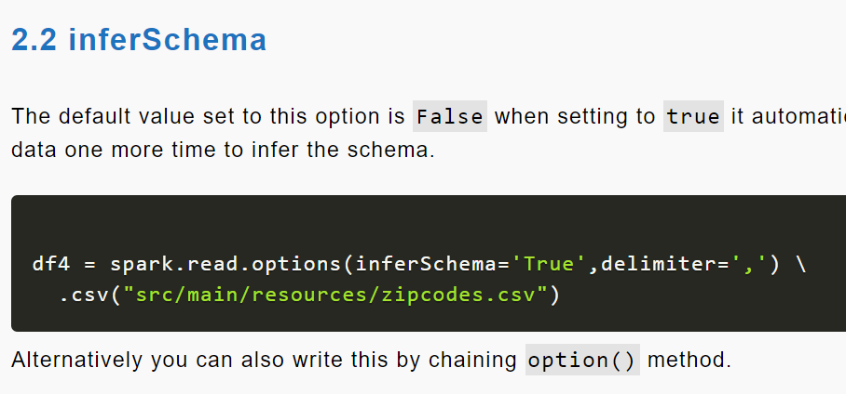

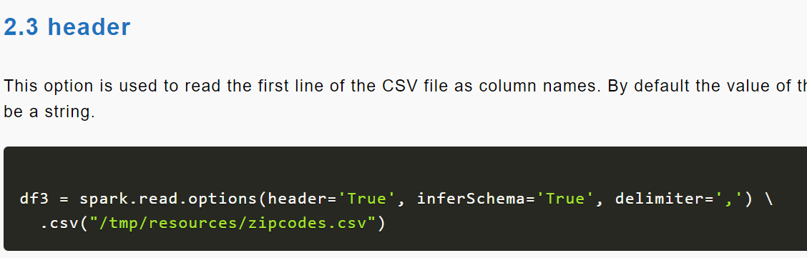

SQL:

**PySpark Window Functions**

PySpark Window functions operate on a group of rows (like frame, partition) and return a single value for every input row. PySpark SQL supports three kinds of window functions:

* [ranking functions](https://sparkbyexamples.com/pyspark/pyspark-window-functions/#ranking-functions)
* [analytic functions](https://sparkbyexamples.com/pyspark/pyspark-window-functions/#analytic-functions)
* [aggregate functions](https://sparkbyexamples.com/pyspark/pyspark-window-functions/#aggregate-functions)

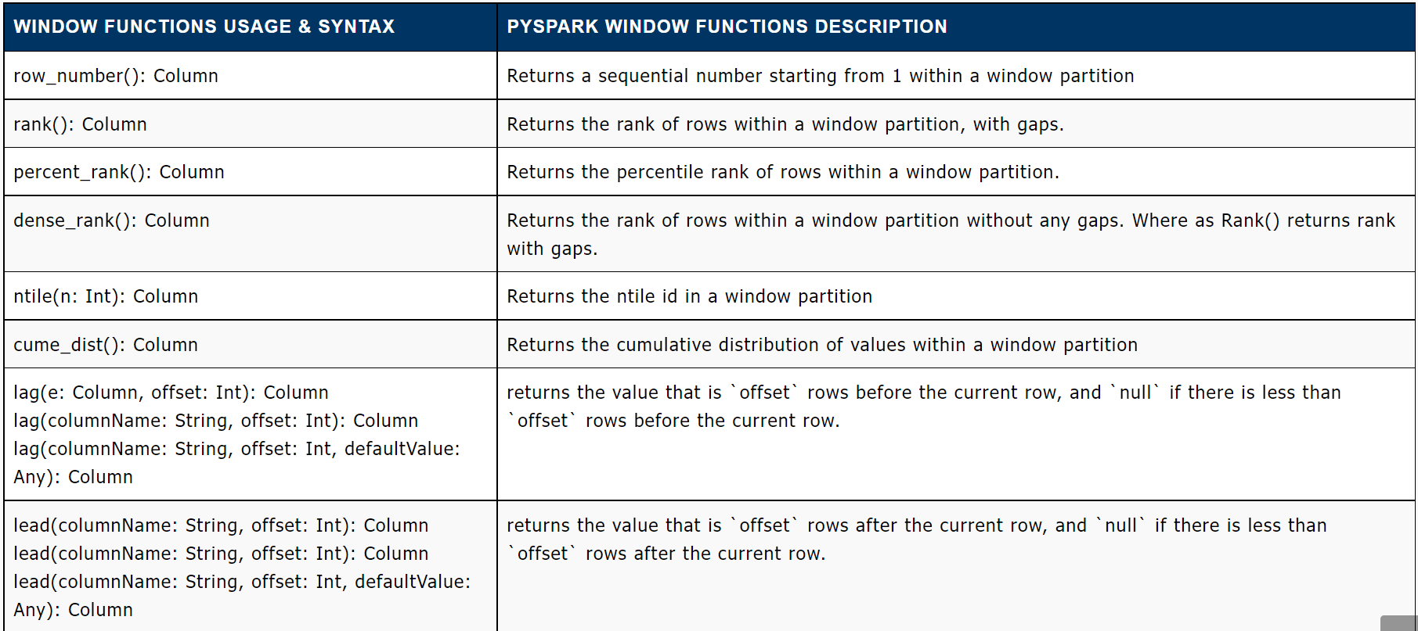

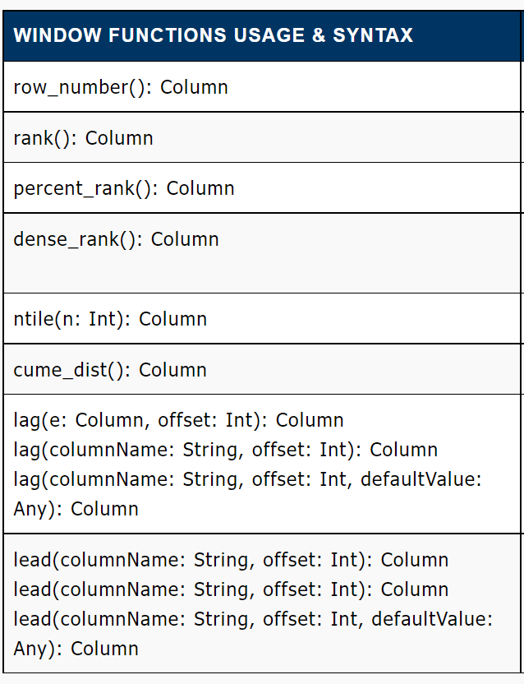

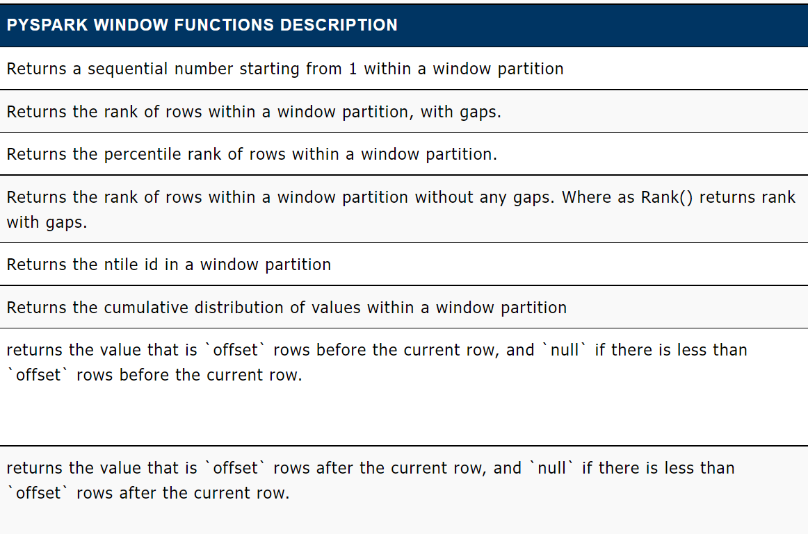

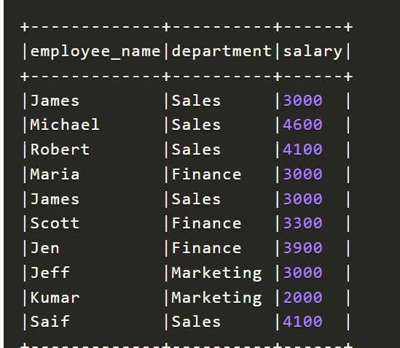

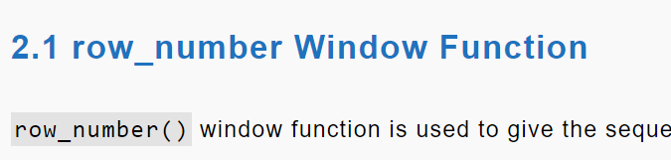

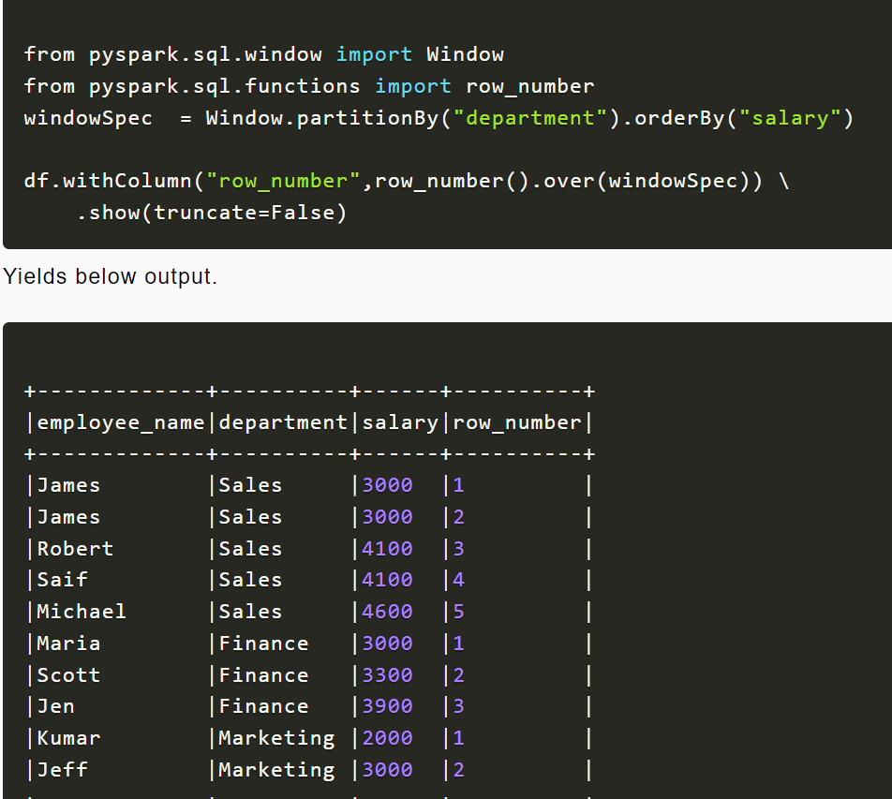

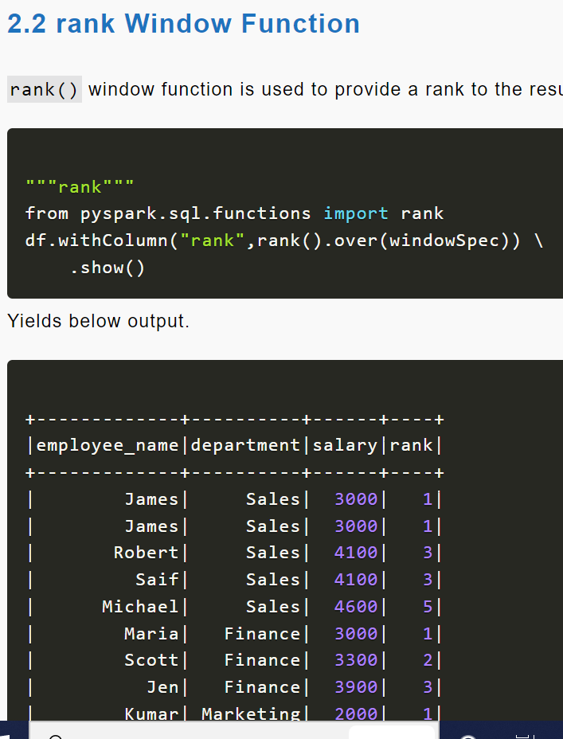

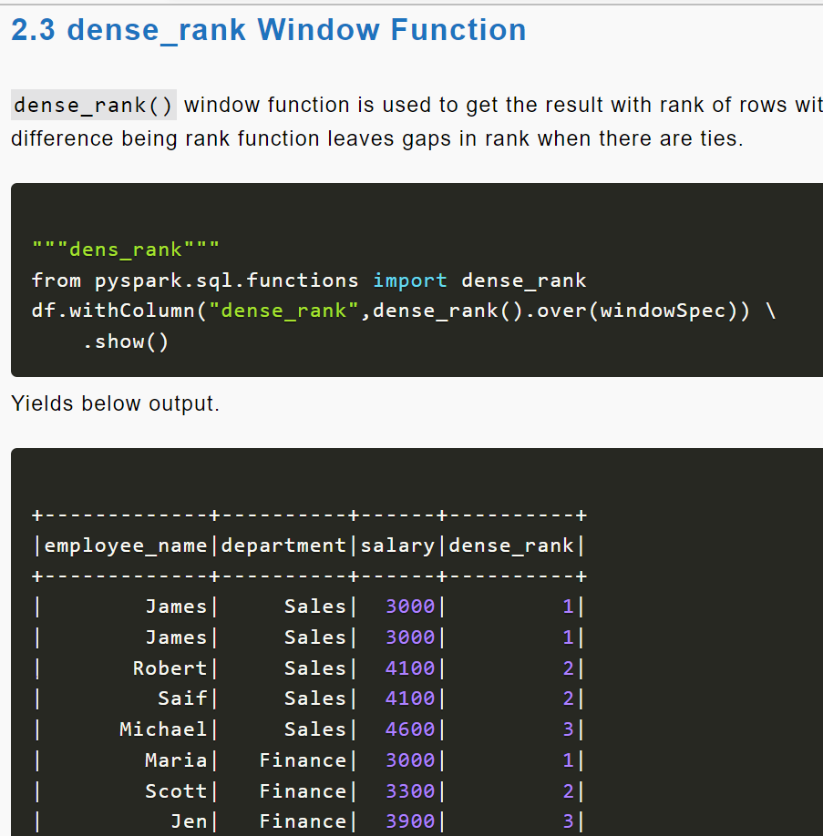

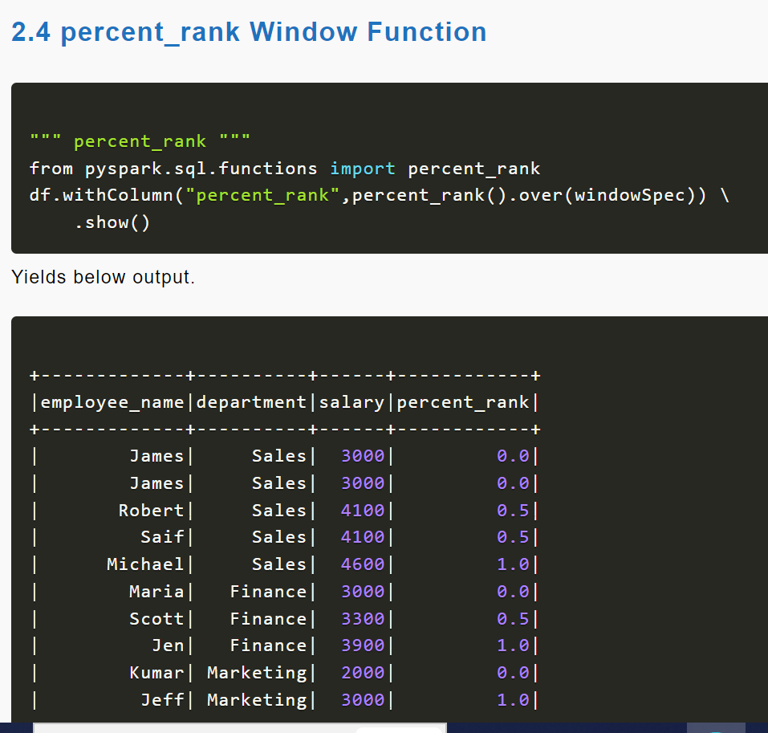

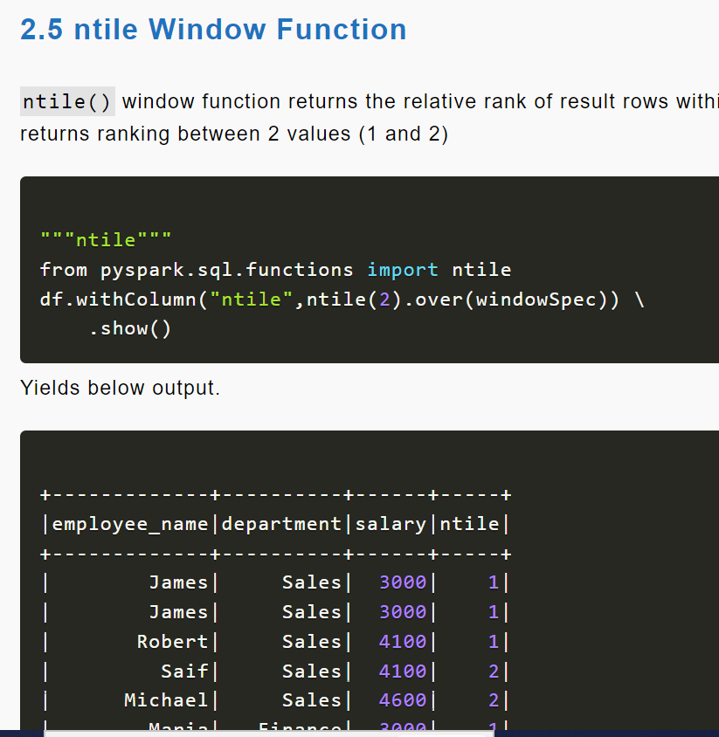

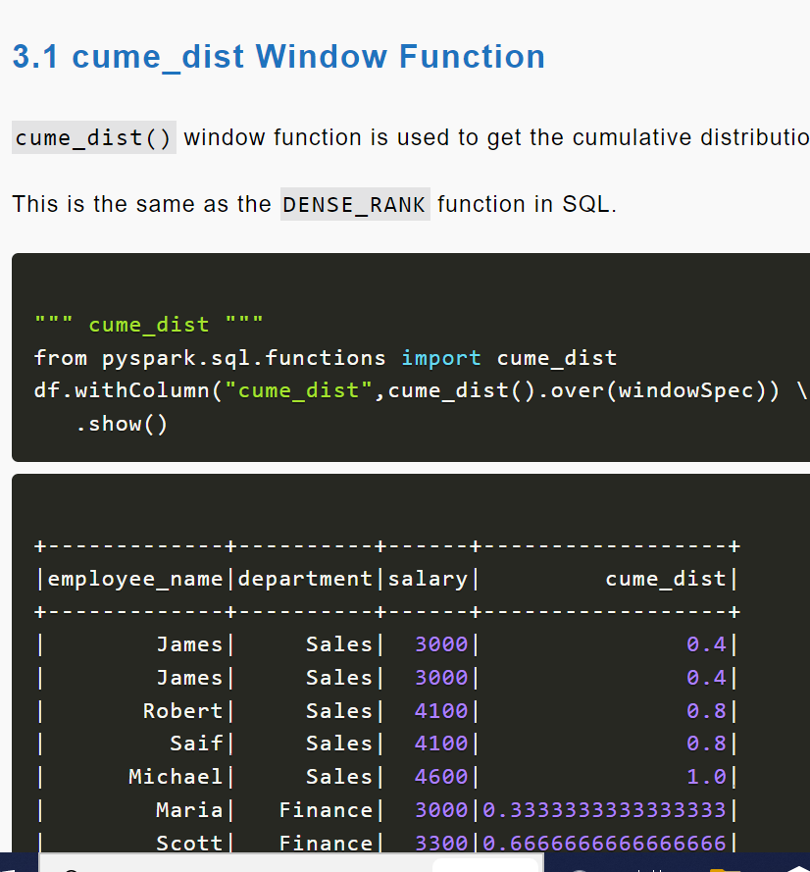

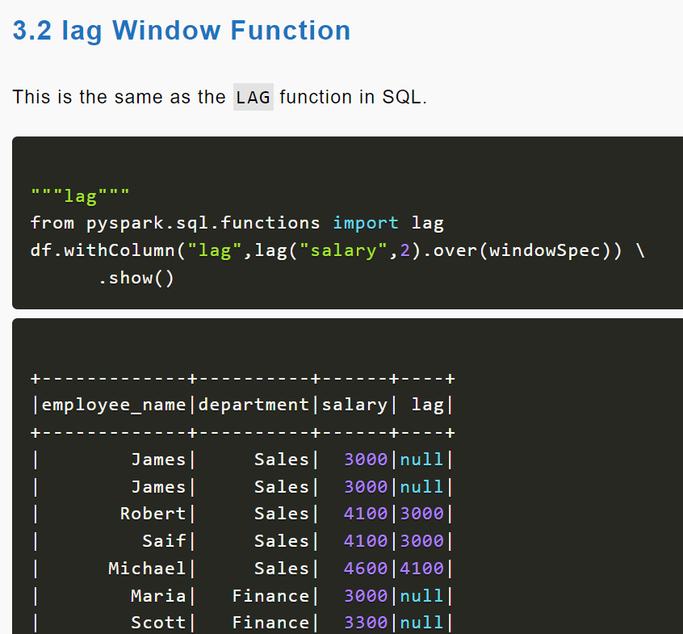

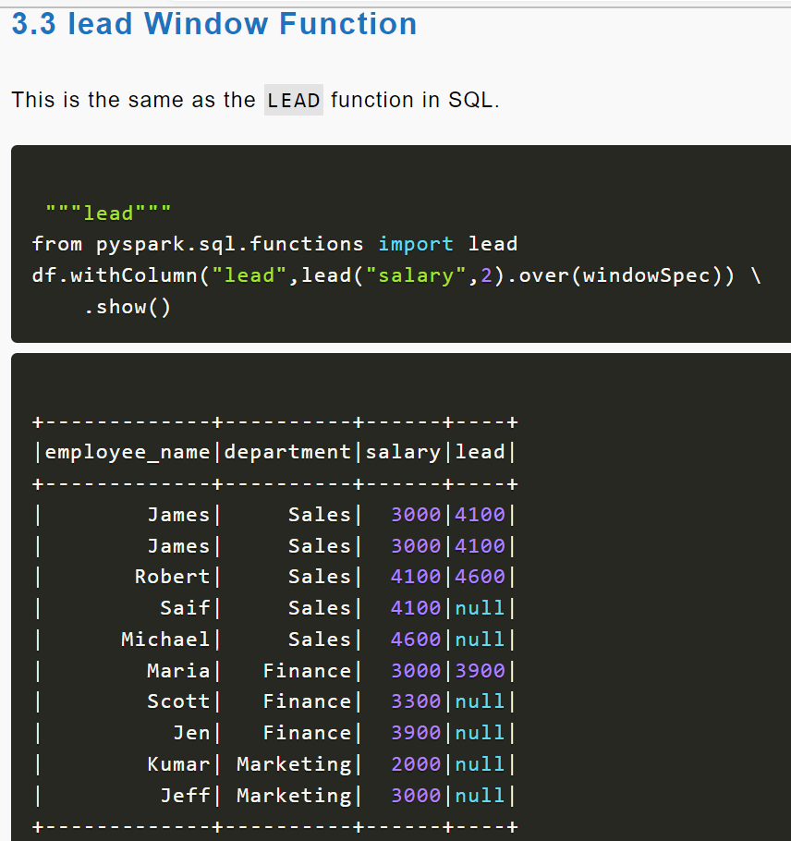

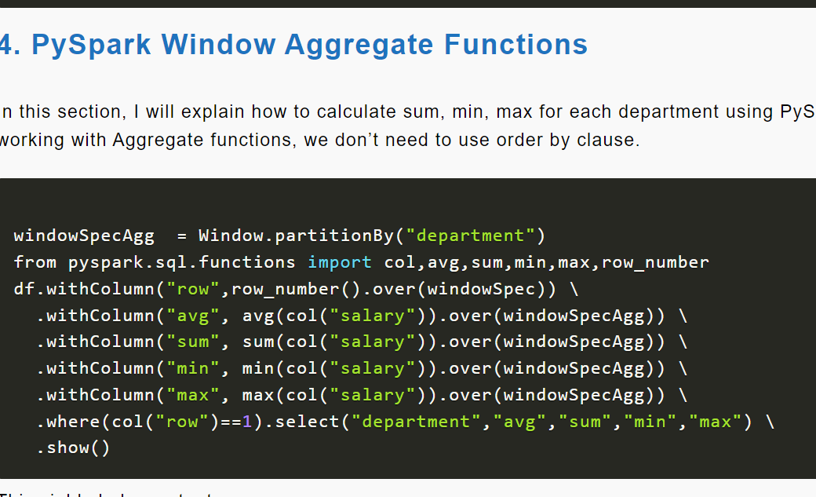

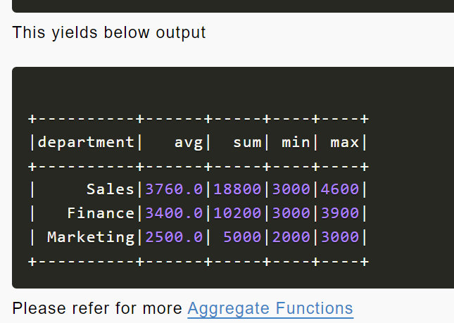

**PySpark SQL Date and Timestamp Functions**

**PySpark Date and Timestamp Functions** are supported on DataFrame and SQL queries and they work similarly to traditional SQL, Date and Time are very important if you are using PySpark for ETL. Most of all these functions accept input as, Date type, Timestamp type, or String. If a String used, it should be in a default format that can be cast to date.

* DateType default format is yyyy-MM-dd
* TimestampType default format is yyyy-MM-dd HH:mm:ss.SSSS
* Returns null if the input is a string that can not be cast to Date or Timestamp.

PySpark SQL provides several Date & Timestamp functions hence keep an eye on and understand these. Always you should choose these functions instead of writing your own functions (UDF) as these functions are compile-time safe, handles null, and perform better when compared to [PySpark UDF](https://sparkbyexamples.com/pyspark/pyspark-udf-user-defined-function/). If your [PySpark application is critical on performance](https://sparkbyexamples.com/spark/spark-performance-tuning/) try to avoid using custom UDF at all costs as these are not guarantee performance.

**PySpark SQL Date Functions**

Below are some of the PySpark SQL Date functions, these functions operate on the just Date.

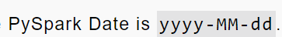

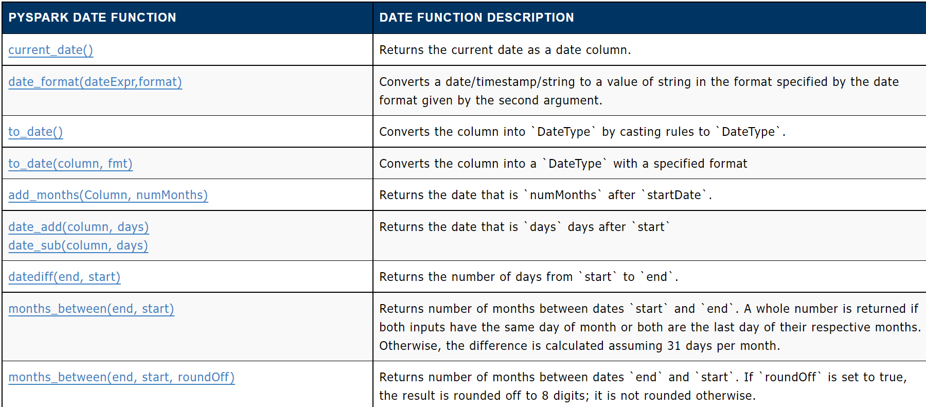

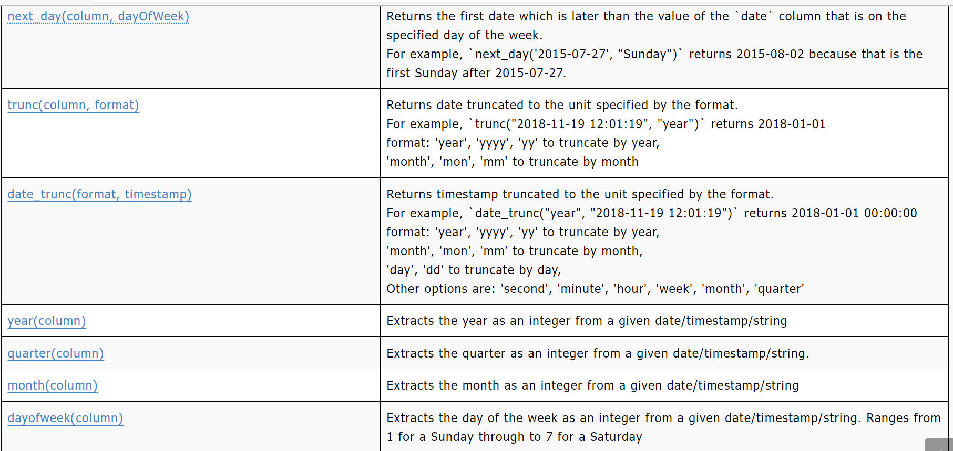

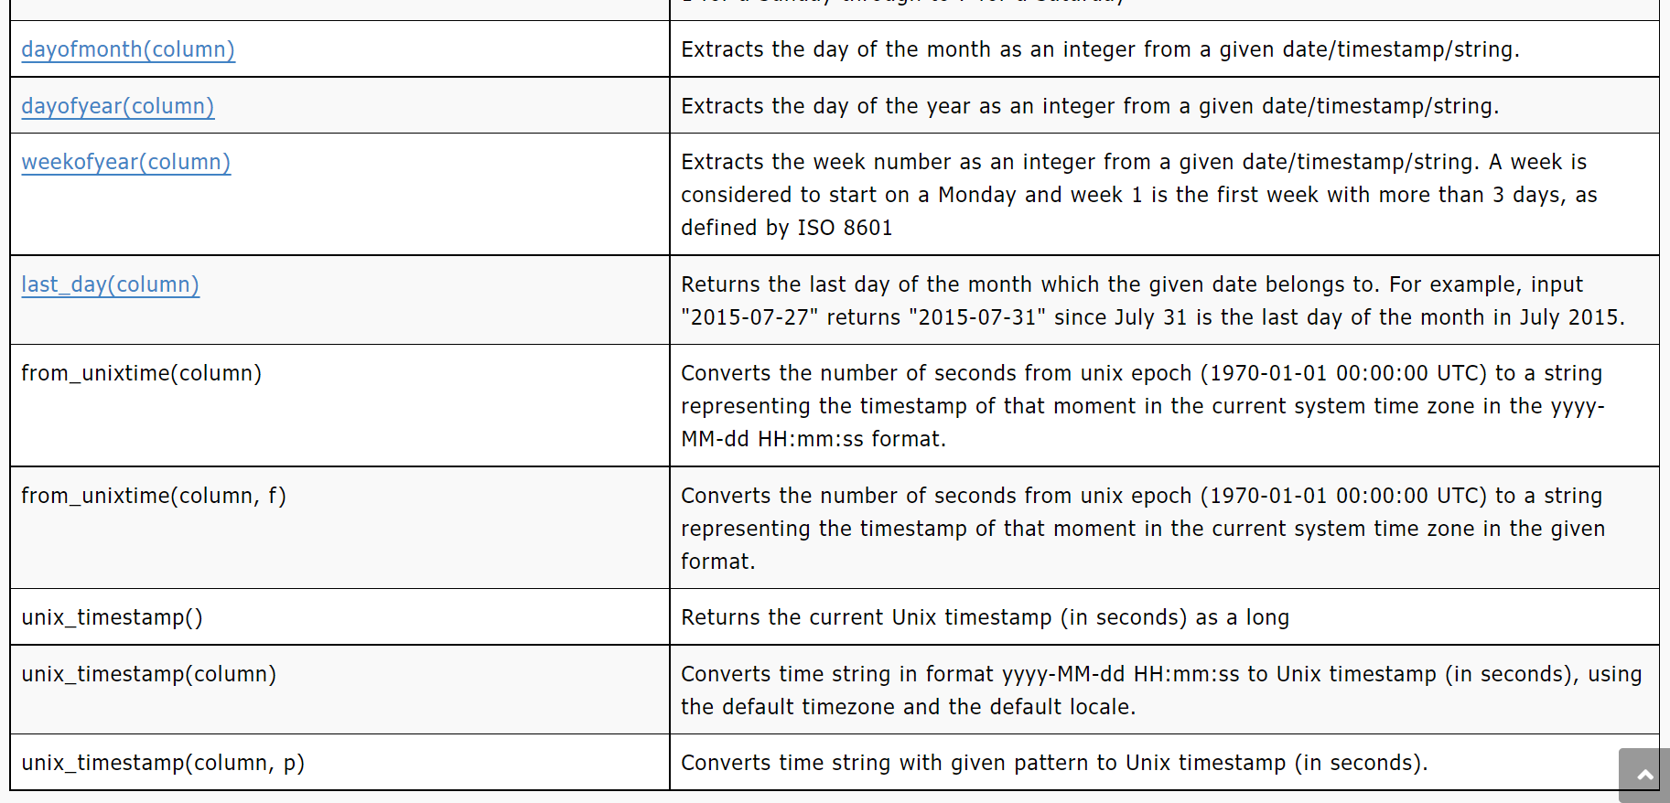

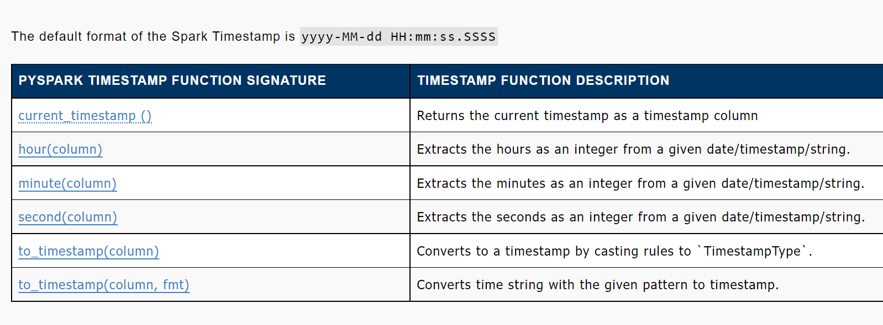

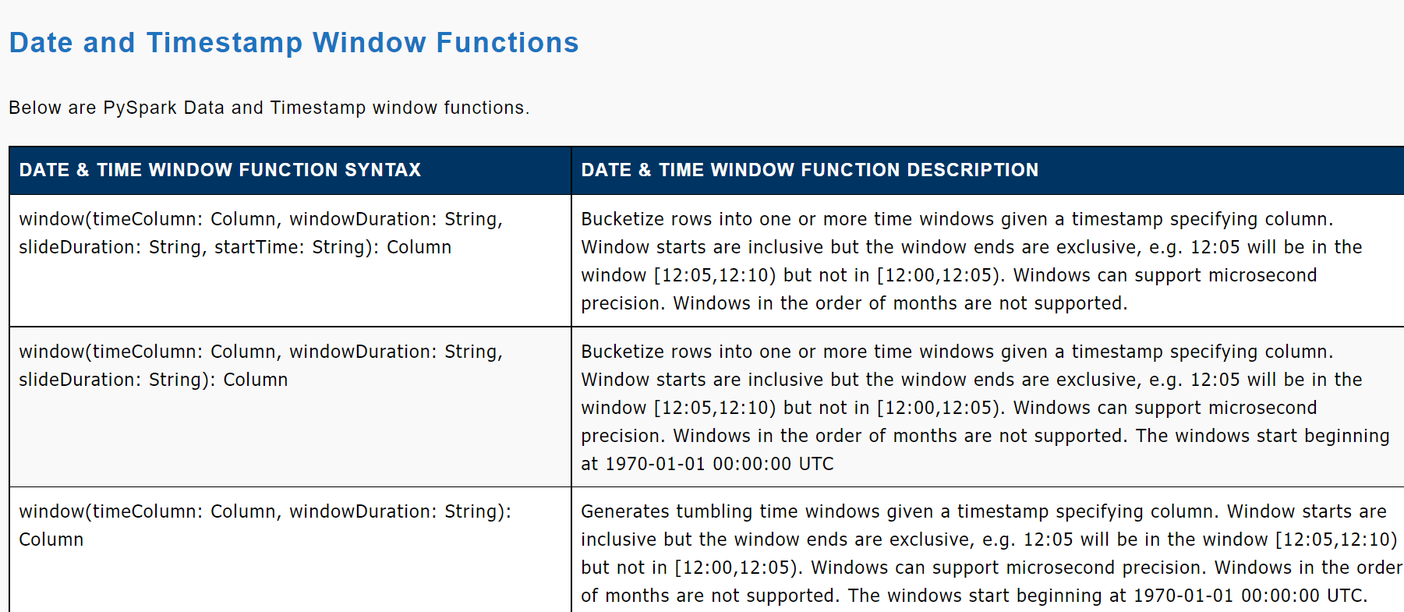

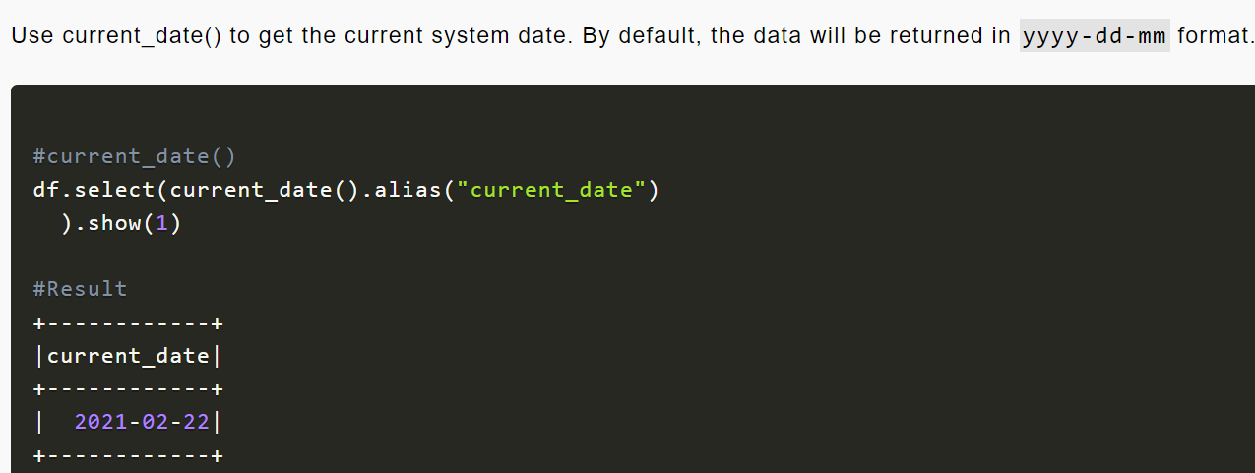

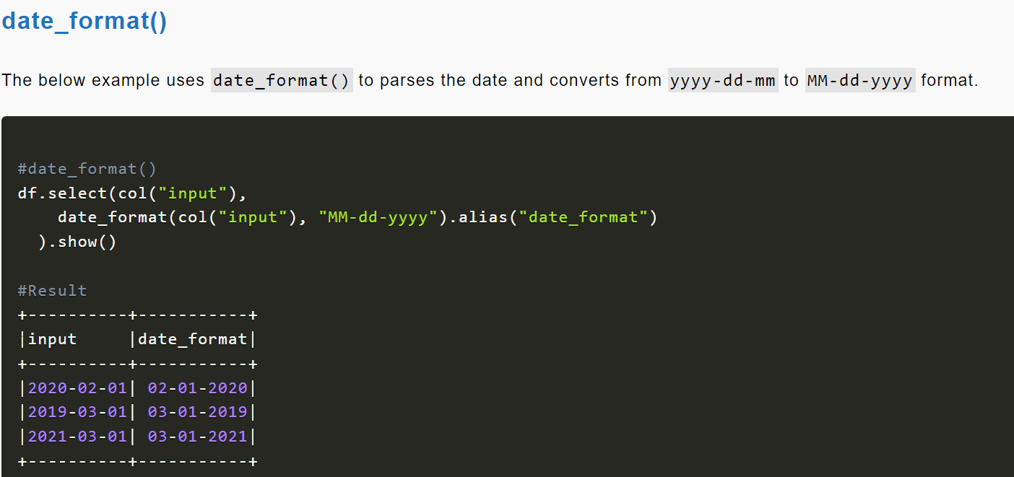

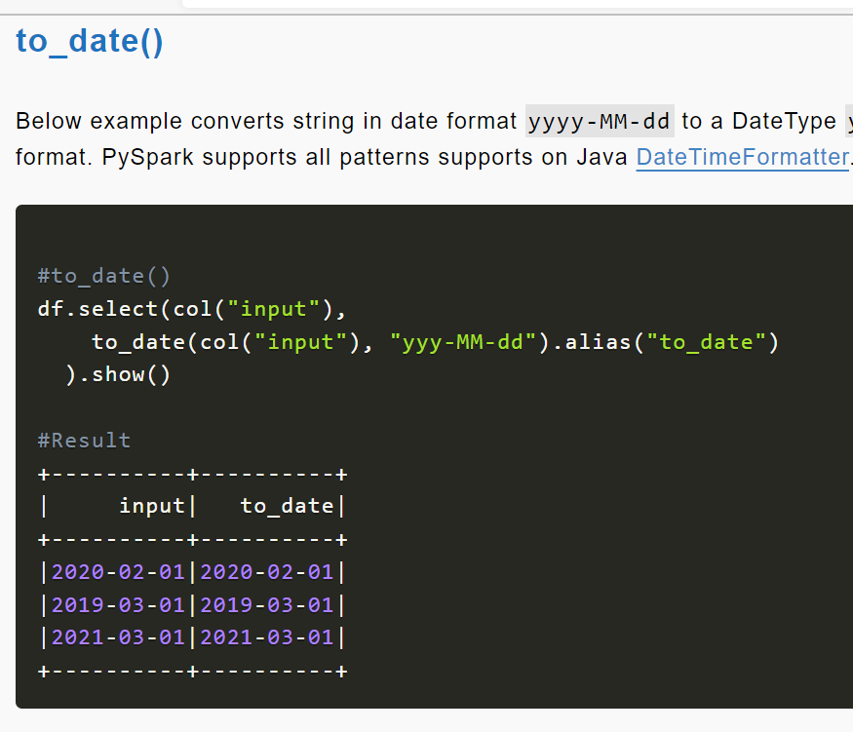

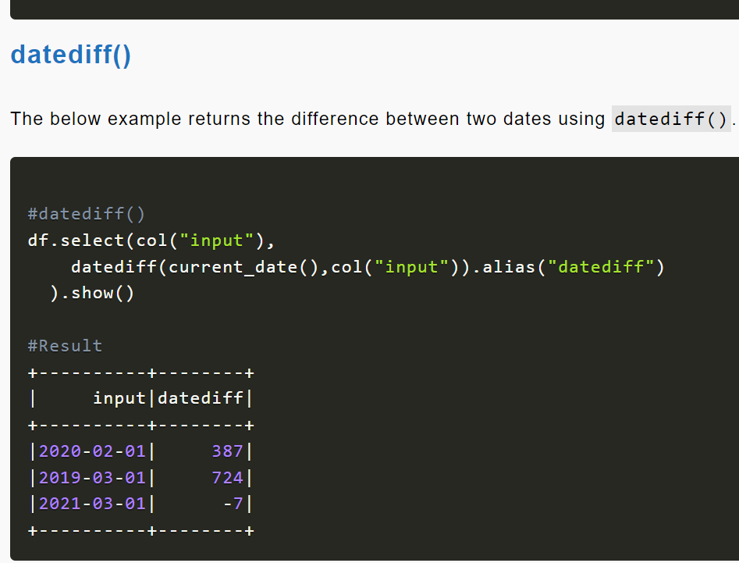

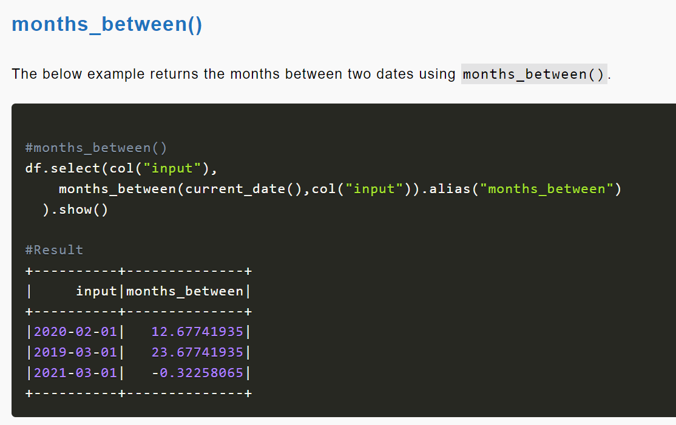

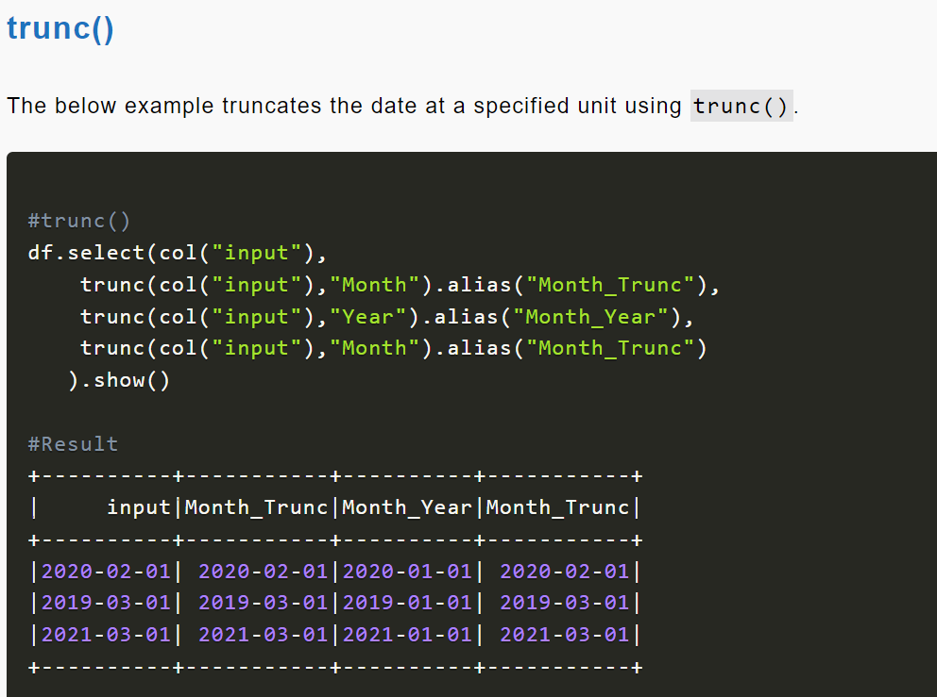

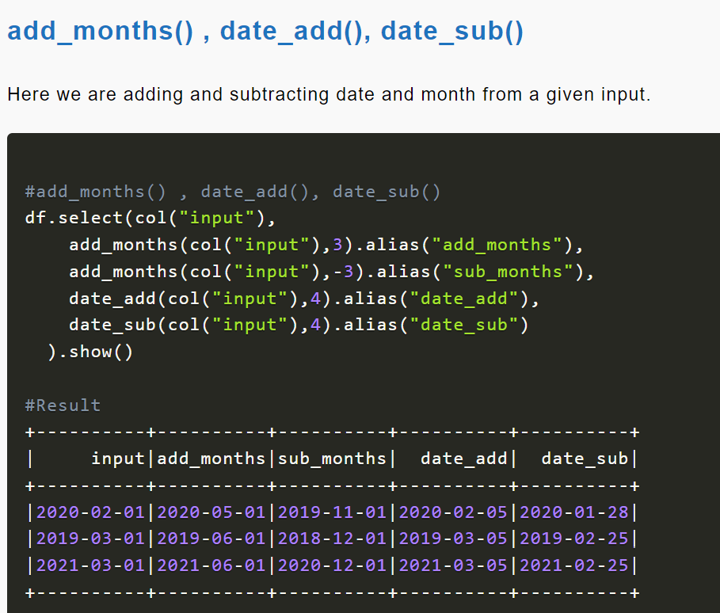

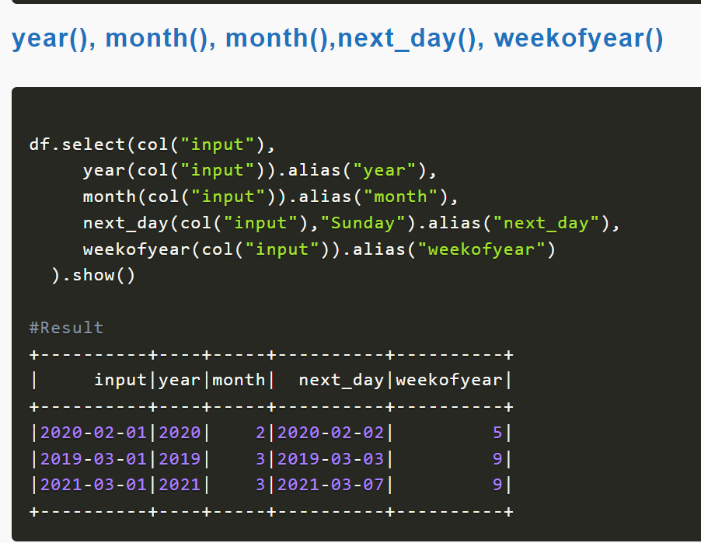

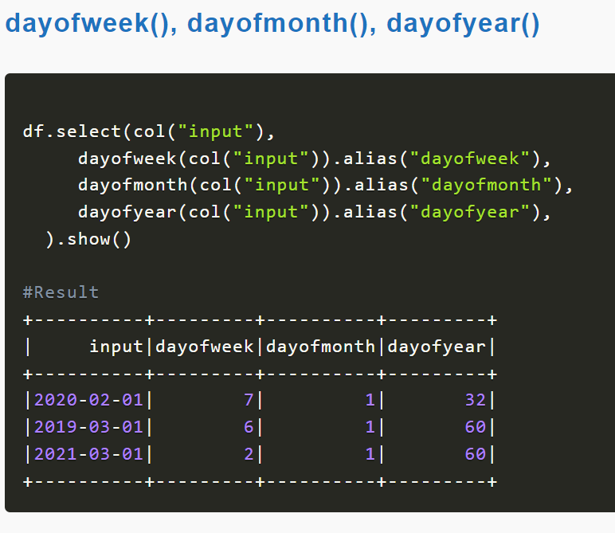

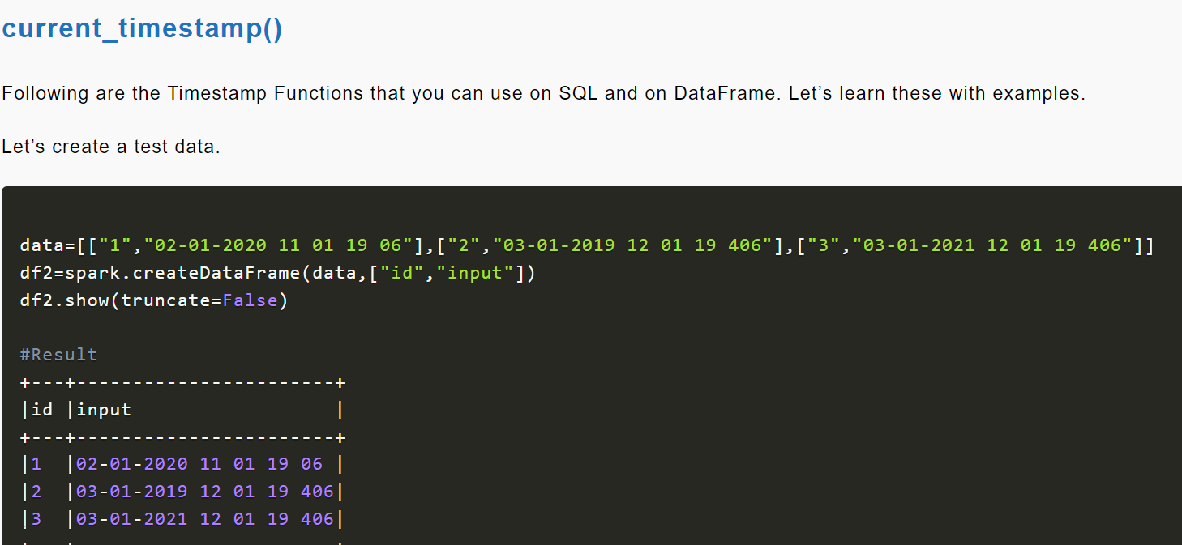

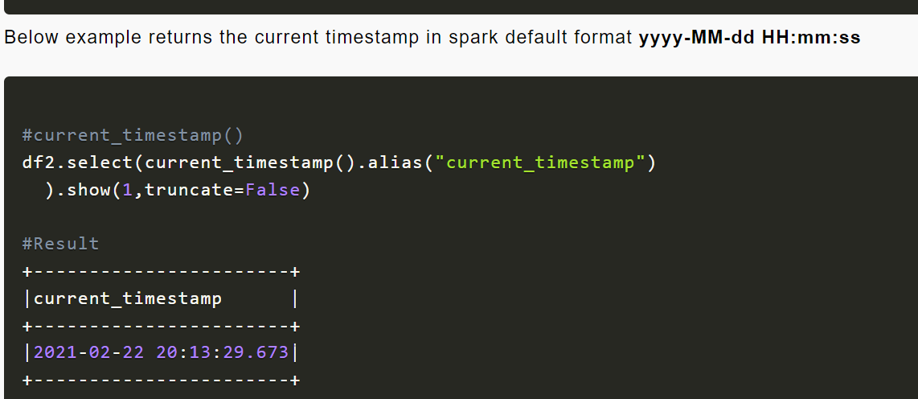

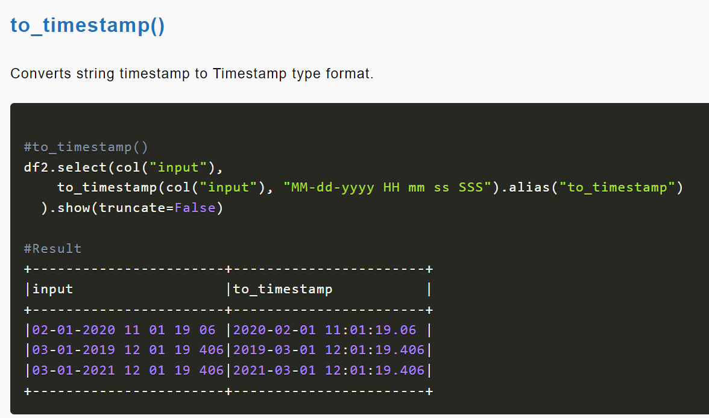

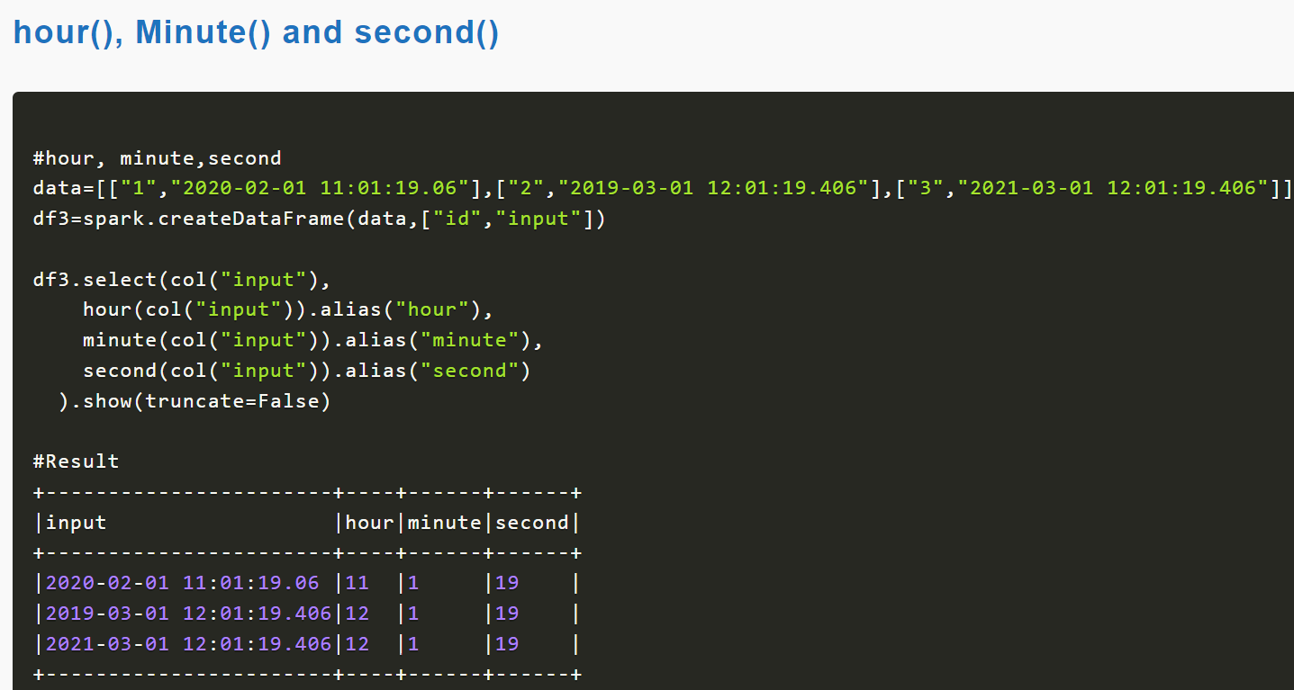

Univerct

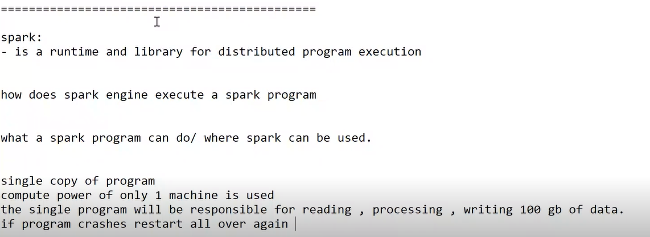

Spark will be addressed that problem

Spark cluster(set of nodes means computers available in closed network)

Preferred os – linus, unix

What installation

Jdk

Spark

Python

Req in every node

The nodes are aware of each other

Contact each other

One of them is master

Other nodes called worker nodes

Spark set up in master node and worker node are same

Configuration is diff for both master and workers

Spark service runs at master node

Master node connect with every worker node

Though hardware can be set differently but used same

Worker nodes should be powerful compare to master nodes

--

Spark programme given address

Programme to read 100 gb data

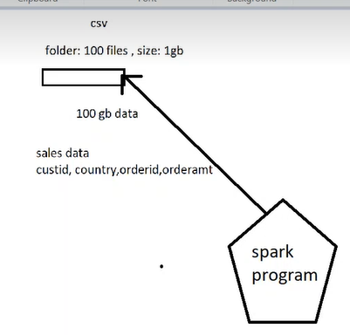

Spari-submit utility will be given along with spark

Where should I write or run(spark-submit)- out side of cluster in any machine

* Spark submit : master will be referred with master url
* 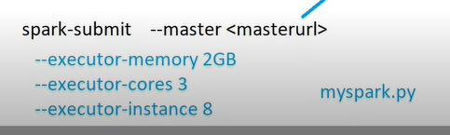
* I can submit my spark programme for master note with spark submit
* This spark programme executed in every worker node
* 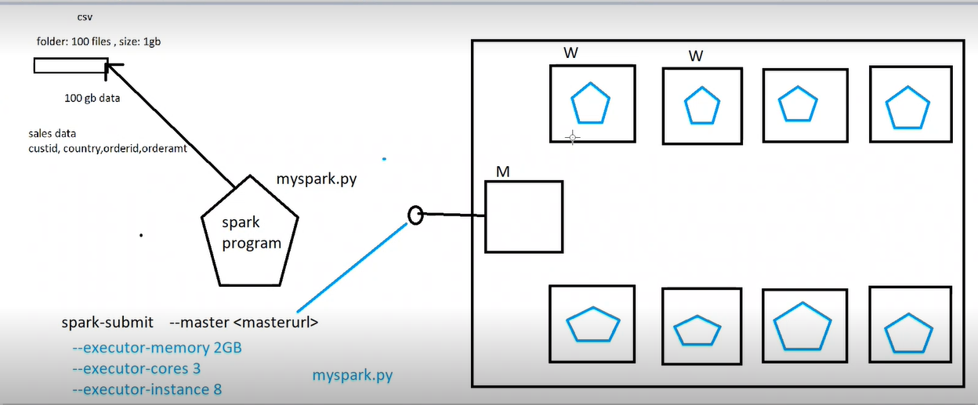

8 copies of pogramme running

Every spark programme given same data folder address

But physical allotment of files will be allocated differently (data )

100 files will be distributed among them

Executor: JVM

Number of worker nodes fixed

I need to mention how many copies of program

--

Master node creates a plan for every worker node

If program executer fails- program fails

Same program will be developed in another node

Spark program should execute it faster

Spark cluster is on premise or cloud

It depends

On prem is costly

--

100gb files we need to distributed among 8 nodes

On on avg avg executer required 14 to 15 gb(over memory required)

Executer core 3

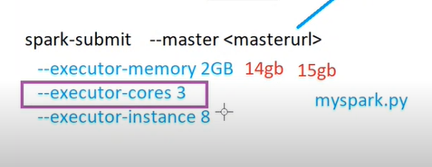

If 3 cores given to each executor

Then memory will be partitioned 3 (each with 5gb)

Not entire 15 gb allocated with data

There ill be some free memory

Map reduce, spark using Hadoop

Diff between Hadoop cluster and spark cluster:

In spark data is not inside cluster

Where as in Hadoop both data and process same inside the Hadoop

--

--

Map reduce not effectively using memory – slowdon the execution of map reduce

--

Worker node have hard disk only for computing purpose in spark not for storage

Spark can do—extract transform and load

Sourse : where spark nodes read data

Sink: where it stores end data

Spark can be used for analyzing hysterical data In real time

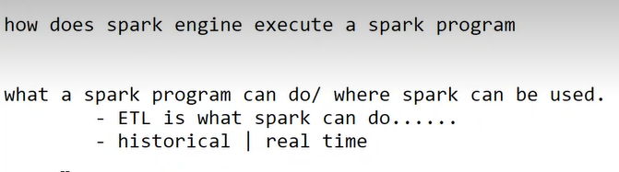

Spark can do faster execution on partitioned data

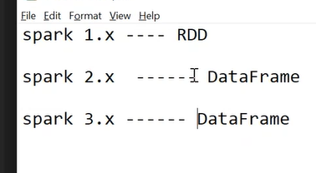

Spark before 5 years – used rdd

RDD:

Resilient distributed dataset: these 3 words shows characteristics of rdd

Rdd is simply a collection

Collection of group of objects

If we load data into rdd- it means data is distributed in diff nodes of cluster

Or distributed across nodes

If we apply filter on rdd – filter applied on 3 notes

[PySpark Tutorial For Beginners | Python Examples - Spark by {Examples} (sparkbyexamples.com)](https://sparkbyexamples.com/pyspark-tutorial/)

2nd advantage resilient:

If executer crashes – rdd resilient or recreated

3. various functions to do transformation

Rdd – immutable

We cant make changes in rdd – if we want to make changes we need to create new rdd

1st program

Sparkconf- spark connfi

Setmaster- url of master- local means our computer

Local[2]- 2 threads- 2 partitions

setAppName- we need to give some logical name

sparkcontext- can create rdd

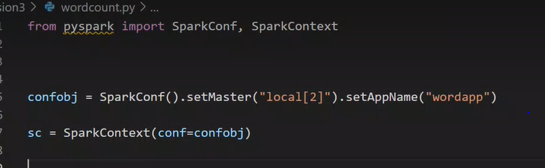

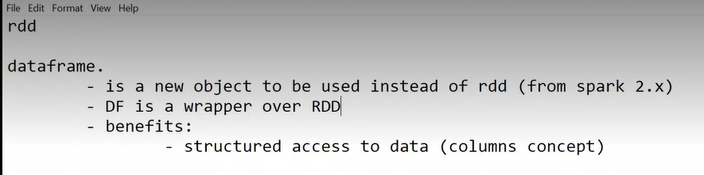

Dataframe wrapper over rdd means internally for dataframe rdd works

So even for dataframe resilient and distribution available

Sql support: dataframe can be shared as sql view/temporary table

It is easy to use than rdd

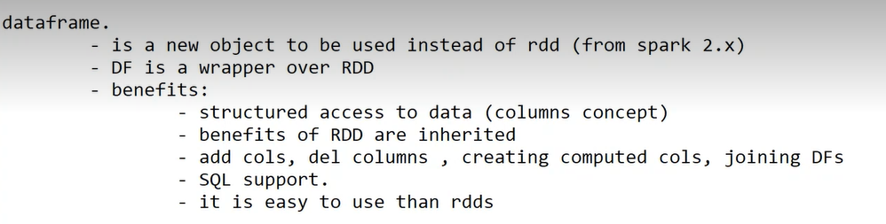

In spark 1.x root object- sparkContext()- capable of creating rdd

Spark 2.x – created another object- SparkSession()- root

Every spark session has internally sparkcontext, sparkconf

To create a rdd with spark session

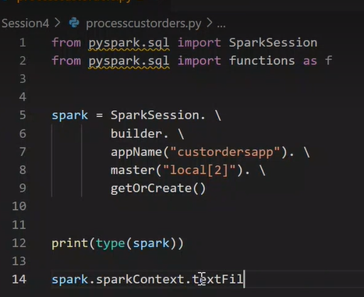

Sparksession is single time instance

Loading dataframe

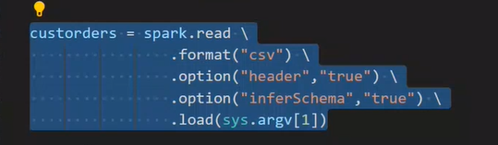

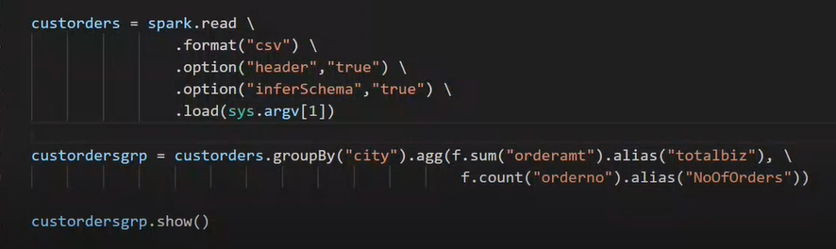

Sys.argv[1 ] 1st command argument in execution in cmd

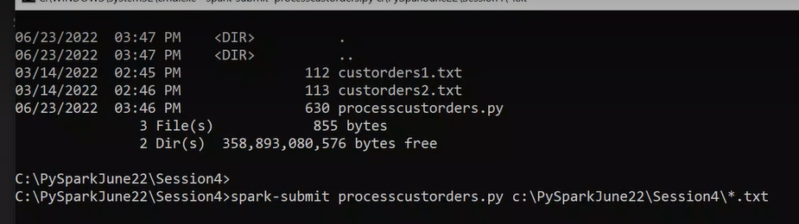

Go to that repo

Spark-submit processcutorders.py “path of dataframe”

This path of dataframe referred as sys.argv[1]

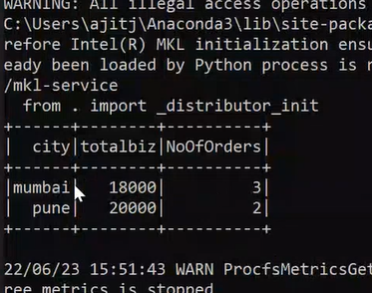

We got the answer

Lecture 4:

To make one partition or force it to create one partition

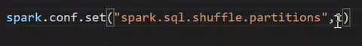

Tis below code created one json file

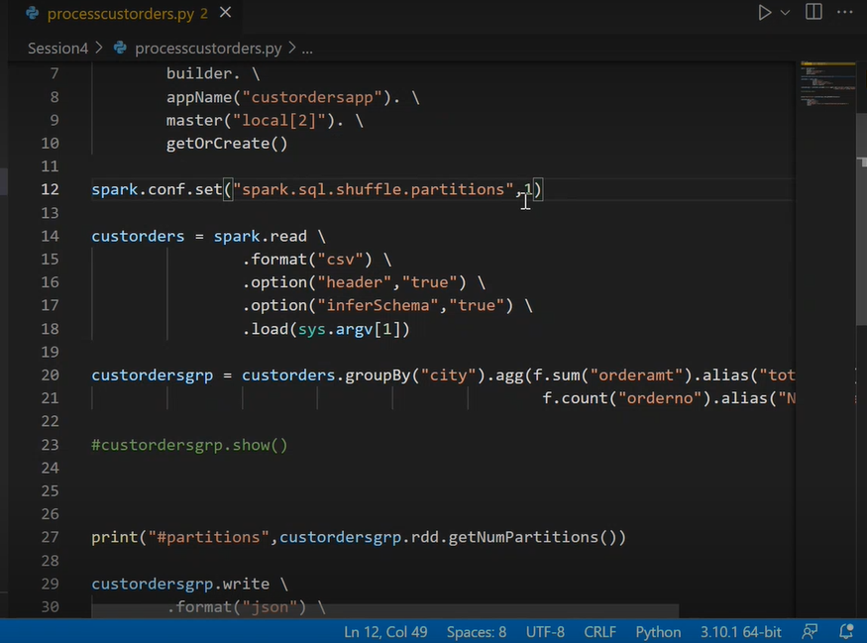

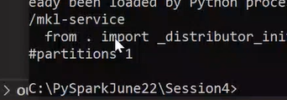

As many partitions those many files will be created

If cluster has 2 worker nodes

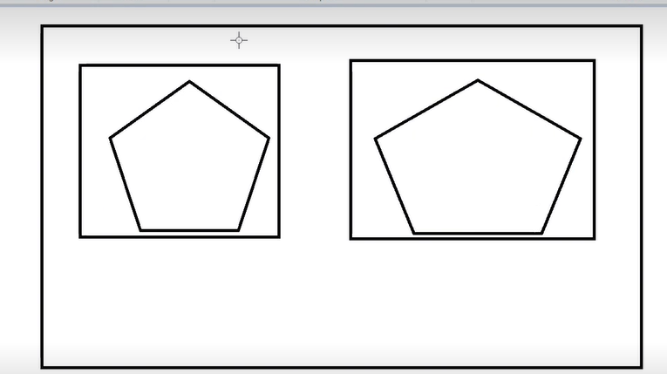

If dataframe had in 5 partitions



Worker node 1 has 2 partition

Worker 3 has 3 partition

When we write them to json file

5 json files will be created

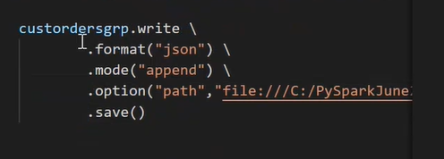

Above write happen for every partition separately

At destination 5 json files will be created

These files created can be input for further spark program

When partitions are more than executor core/threads/slot- there will be waiting time- one partition should wait

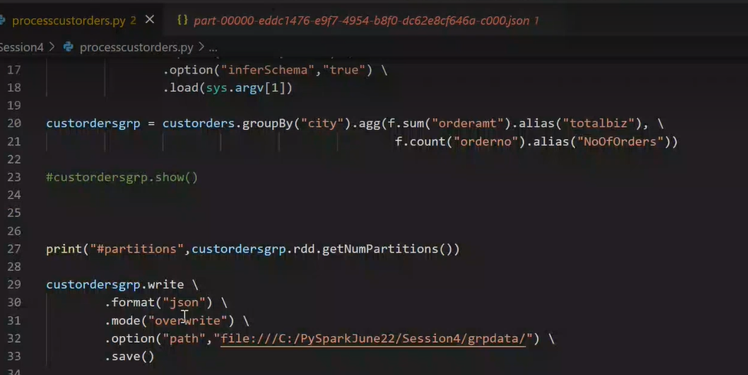

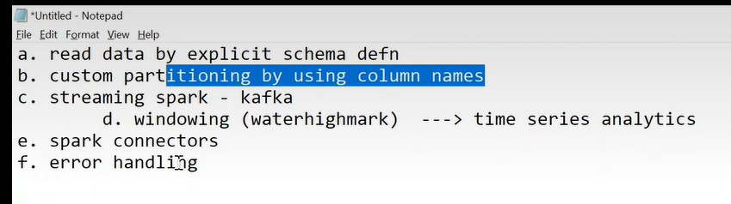

6th day

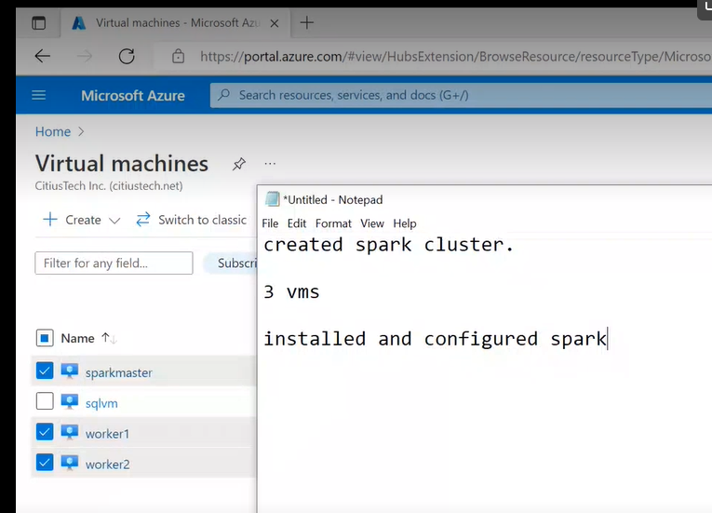

3 vertual machines created 1 as master